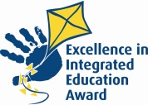
Braidside Integrated Primary

and Nursery School
87 Frys Road, Ballymena Co. Antrim BT43 7EN

028 25647899 Principal: J McAuley
www.braidside.co.uk
25/02/19

Dear Parent,

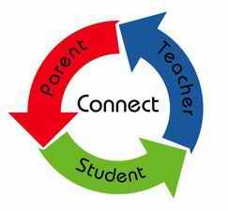
Thank you for your attendance and participation in our recent Parent Interviews. Parent involvement is one of the core principles of our integrated ethos and we encourage parents to always contact the school and/or the class teacher should you wish to discuss your child’s progress or other important issues. We aim to listen and work in partnership with parents and are grateful for your support and assistance. Parents will receive their child’s end of year report in June 2019.

CS Moments Photography will be in school from Monday 4th until Wednesday 6th March, 2019. All children will have an individual photograph taken and sibling/ family photographs if required.

Confirmation
Congratulations to our P7 Catholic RE group who celebrated the Sacrament of Confirmation on Tuesday 12th February in All Saints’ Church, Ballymena. The children participated so well through the ceremony in the prayers, readings and singing. It was a wonderful day and we were incredibly proud of all the children.
Thank you to Mr O’Sullivan, who prepared the children and to all the parents for their support.

March is Integrated Education Month and the theme for this year is “Perspectives”. To celebrate Integrated Education, we will be having a number of activities occurring throughout this month including an art competition, writing/drawing activities in class and on 22nd March we will celebrate Odd Socks Day, when we ask children to come to school in their uniform as usual but wearing odd socks instead; as colourful and wacky as possible. A donation of £1, on the day, will support the work of the Integrated Education Fund; who supported the school in the beginning and continue to be involved.

Some dates for your diary:

WORLD BOOK DAY: THURSDAY 7th MARCH: Children may dress up as a character of their choice if they wish.
There will be further information about World Book day activities forwarded to parents in the days ahead. Please visit our website and Facebook page for up-to-date information.

First Confession (P3 RCRE children): Wednesday 27th March, 2019 @ 10.30am

First Holy Communion (P4 RCRE children): Sunday 26th May, 2019 @ 10am

Shared Education visits and opportunities will continue throughout this term for P1- P3C. Please visit the school website to view the calendar with dates for these days.

Yours faithfully,

J McAuley

