Week 5 Monday 18th May 2020
Good Morning P5F!
Ola!
I FOUND THESE PHOTOS OF ME THIS WEEK ON MY SCHOOL PAGE- PARKHALL OLDIES! CAN YOU SPOT ME?
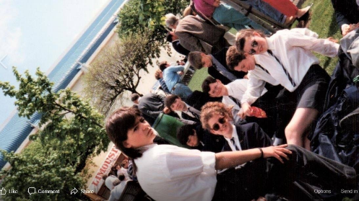
P7 Year 11 Year 9 (recognise this door)
So, how was your week of sports? Please remember to send in your photos. It is important we all keep in touch. This is the new norm for a while now. Thank you to all those who continue to send in their work, their daily home activities, photos, stories, poems, letters and comments! It is vital to me, as your teacher, to know what works well for your learning at home, and what aspects you enjoy, or what areas you need focus on.
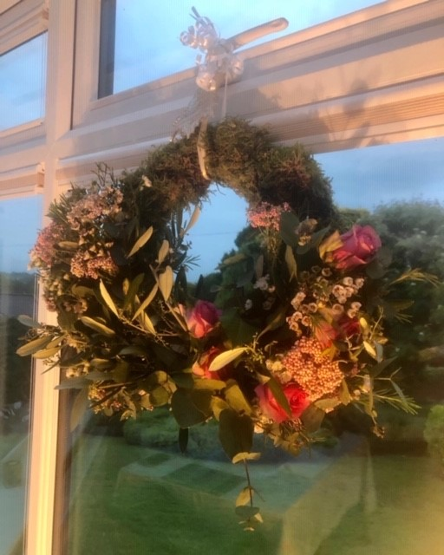
This week we had a birthday in the family- the boys’ granny- my mummy in law. It was very different to what we normally do to celebrate her and thank her for all she does for us. Last year we had a party for her in Oranmore, this year she celebrated at home, without all of us physically there. We did however get her two activity gifts this year- a wreath making kit of fresh flowers, and a cook at home box From Chef Jeffers from Forestside Cookery School. It kept her focused and active for two days this week anyhow. She surprised herself with how creative she can be with flowers!
Have any of you had any family birthday celebrations with a difference since Lockdown? Are you able to send me any pictures (with permission) along with a little write up? Pupils are loving seeing each other ‘at home’ on the school website...

This week, we are back to literacy and numeracy tasks. Make sure and plan out your days for your tasks- you know what works best for each of your home environments. I love seeing what way my eldest plans out his week each Sunday... you can see this in the little video that will be posted later in the week. 😎 Why not send me a pic of your week’s plan to post for others to see. It may help others plan their week differently and more effectively.
So here goes.... let Week 5 term 3 commence:

- Literacy
First News- Keeping up to Date with World News!

- Reading and Comprehension- Access the First News document- the entire paper is there accompanied by activities. Levels 1,2 and 3 are also uploaded. Have a go! Any why questions, or what do you think questions- I want you from now on to focus on explaining your reasons- answers extending to a good full paragraph. If you have a further reason to add- make this a second paragraph and so on. Correct spelling, grammar and ensure punctuation has been used properly.

- Creative- Poetry- Michael Rosen- michaelrosen.co.uk
Please view power point- My pupils love this poet and story writer. Are you familiar with We are Going on A Bear Hunt story? My boys enjoyed it as babies. Oliver created the Powerpoint for a poetry homework he had. (view this in downloads)We decided to do some research on Michael Rosen and found out lots of interesting information. His views on teaching poetry, given in an interview were refreshing and reassuring- read to find out!
Watch three of his poem readings- perhaps the ones Oliver focused on- Which ones can you connect with/identify yourself with? His has brilliant facial expressions! His power point has hyperlinks to take you straight to the poems he enjoyed.

Have a go at creating your own Learning from home poem – using his style perhaps?
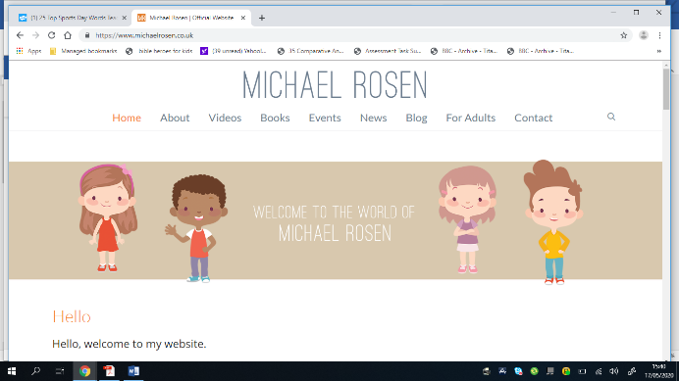
Michael Rosen Website link (control & click to follow link)

- Grammar- Punctuation tasks-
Please see downloads for these documents- Twinkl .
I am uploading grammar tests from Twinkl- these incorporate a range of skills. These will be helpful for your child’s P6 year. Answers are included.

- Spellings - focus- Mental Health and feelings
Can you sort these spellings into three groups?
POSITIVE FEELINGS
NEGATIVE FEELINGS...
REMEMBER these can vary, depending on your situation- it can be good to be hesitant if asked to do something wrong, but it may not be good to be hesitant to follow good, safe advice from a parent for example. Discuss each of the words- how do you view these words? Can they go into the other group and when?

Irritated
Elated
Joyous
Exasperated
Overwhelmed
Victorious
Despondent
Hesitant
Impatient
Intolerant
Satisfied
Disappointed
Relieved
Courageous
Uncomfortable
Determined
Can you add four more words- two to each set.
Test child and allow child to also test adult on spellings.

- Reading- Book Post
Can you record a one/two minute video of you with your favourite book, sharing why it is your favourite, characters in the book and something interesting about the author? Don’t forget to hit ‘SEND’ to my email!😁
cfulton436@c2kni.net

- Numeracy
Number work and Problem solving- see downloads
Tasks this week cover a variety of skills- number, addition, subtraction, division, square numbers, prime numbers, perimeter and area of shapes and probability. I will add in hyperlinks for different tutorials for you to watch online. There are countless short clips available online for children. Always seek adult permission for access. To help refine your search add in keysatge 2 for your chosen topic for any video tutorials- remember not all schools/countries use same methods for addition and subtraction.

Online Links for each topic below.... (control and click to follow link)

Prime and Composite Numbers
Square Numbers
Probability 1
Probability 2
Perimeter
Area
- PE
With Joe Wicks on Youtube- Lots to choose from!
Are you exercising daily? How long for each time? What types of movement activities are you enjoying?
Click here for PE with Joe Wicks (control & click to follow link)

- Staying in Touch Task... important for Mental Health as well as Home Learning/Schooling
♥cfulton436@c2kni.net - email any requests for specific work tasks
♥Email pictures or scanned documents of work (phones have scanners)
♥Email me websites you are using for any home-schooling activities
♥Sports activities from Week 4
♥Any birthday celebrations photos and write up
♥Connect with Braidside Facebook Page
♥Check our website daily for new updates on home page
♥Braidside.co.uk class pages for weekly tasks and a peak at classmates’ photos. here’s the link..... (CONTROL & CLICK LINK...)
👉BRAIDSIDE WEBSITE FOR HOME SCHOOLING👈
♥Are you in touch with any classmates- let me know who with and how you are communicating with each other 😊
♥How are you staying in touch with family? We are enjoying Zoom calls with the family, Saturday night family quizzes and Zoom music lessons for the boys!
♥Your teachers stay in touch during the week using Microsoft Teams calls and chats as well as Whatsapp and emails. One teacher managed to do their Teams video call upside down, on their head! 😂 Any ideas who that was?

This week’s Challenge!
Mental Health Awareness Week this week- as we as a school are 30 years old... can you do 30 acts of kindness in the week? Now there’s your challenge for this week! Keep a list of your daily acts of kindness in the week and email them to me! We know Braidside pupils have Big hearts!💖
There are lots of activities above to focus on and learn from this week. Remember the key to success is to plan and use your plan! Do what you can!
🕗Set the alarm-keep a healthy and productive routine🕗-
allowing downtime too of course with friends and family- however you do that now.
🌈Stay Home
Stay Safe
Stay Connected 🌈
Stay in Touch! From Mrs Fulton.

