P4/5M – Week 5 (Term 3)
Week beginning 18th May, 2020
Hi P4/5M
I hope you are keeping well and keeping safe. Did you see the posters made by the staff of Braidside? Everyone wanted to send a message to all of you. They were on the school website and facebook. My message to you was, “You are Amazing, You are Brave, You are Strong” How are you coping with the home school learning? I would love to hear how you are all getting on. In my house Ben is finding it easier. He gets his assignments on a Monday morning for the week and then he plans out which subjects he is going to do each day. He is now trying to fit everything into 4 days so that he can have Friday free. This has helped to motivate him. Harry can still find it tough and would rather be back in his classroom with Mrs O’Neill and his friends. He worked hard this week and Mrs O’Neill said that he could have a treat so he opted for Domino’s Pizza. This was a lovely treat for all of us on Friday evening. The boys were delighted and I didn’t have to cook so it was a win-win situation for all of us! The weather was colder with some rain this week but I hope you still managed to get outside to do some exercise. I’m still walking Barker, my dog every day and I’m still running 3 times a week and it isn’t getting any easier! Also, poor Barker needs to get a haircut so I can’t wait until the dog groomers reopen.
Below is a guide for you to use this week. Remember, it is only a guide and I wouldn’t expect you to cover everything on this list. Just do as much as you can. Pick a few things you would like to do and then plan out the days you are going to do them. I’ve uploaded a home learning timetable for you to fill in. I hope you find it useful.
As it is Monday, you can still follow our normal Monday routine. Spellings, Jolly Grammar Workbook, dictionary workbook and Comprehension. World Bee Day is on Wednesday, 20th May. I’ve uploaded a comprehension called ‘All about Honey Bees’ and a variety of activities on Bees. This ties in well with our TWAU topic – ‘A Walk in the Park’ so you might want to use the Bee comprehension instead of the one from your pack
Weekly Fact – for you to copy into weekly facts book.
Triangles - are shapes with 3 sides and 3 corners. There are 3 triangles that I would like for you to know. An Equilateral triangle, an Isosceles triangle and a Right Angled triangle. The inside angles of a triangle add up to 180° (We looked at triangles in term 1 so this should be revision)

Name of Triangle | Picture of triangle | Facts about Triangle
Equilateral | 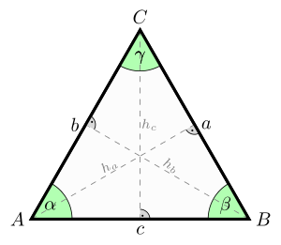  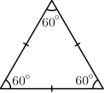 | - It has 3 equal sides  - It has 3 equal angles measuring 60°  - It has 3 lines of symmetry
Isosceles | 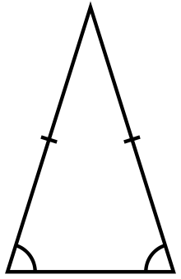  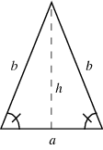 | - It has 2 equal sides  - It has 2 equal angles  - It has one line of symmetry
Right-angled | 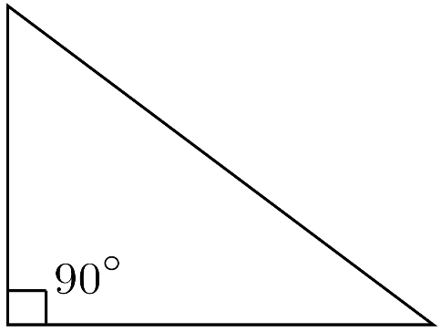 | - One of its angles measures 90° (Right Angle)

I’ve uploaded a power point about triangles to help you and a Triangle Hunt sheet to use in your home and garden.
Vocabulary Genie – Word of the Day. Our word this week is ‘mystify’ – I’ve uploaded a worksheet for this task so you can either print it off or write the word into your Literacy Classwork book.
Also for Literacy, I’ve uploaded a variety of literacy worksheets on Bees. You might want to use them this week instead of the other literacy booklets and the New Waves English.
Finally, for Literacy ………don’t forget to spend some time reading each day. Reading is so important. Mrs Young will be uploading the First News newspaper and activities. Remember, we would have been using level 1 activities this term.
Numeracy
Similar to what we would be doing in class, remember to start off every morning with your New Waves Maths followed with some mental maths games. Remember to spend some time each day revising your multiplication facts. This week I’ve uploaded some sheets on taking-away using HTU’s – some have exchange and some don’t. Remember, you don’t have to print these sheets out as you can copy them straight into your numeracy book. These sheets will be good for revision.

TWAU – World Bee Day
This week I would like you to research information on bees for World Bee Day and find out why we now have a World Bee Day. Find out where World Bee day began and why do we need to protect our bees. I will upload a variety of things to help you. Once you have your research done you might want to record your information onto “Earth Day Save the Bee” Activity sheet.
Sheets to help you include the following -
- Earth Day Save the Bees activity and teachers guide
- World Bee Day information
- Bee facts cards
- All about bees worksheet
- How honey is made
- Bee Powerpoints – All about the Life Cycle of a Bee and The wonderful world of Bees.

Being Creative - This week I’ve uploaded another ‘Character Sketch’ activity. This week you will get the chance to create a ‘Villain’. I think that this would be lots of fun! Think about all the Disney Villians ……. Scar from the Lion King, Cruella de Vil from 101 Dalmations, Captain Hook from Peter Pan to mention a few. Again, you don’t need to print this out as you can write it straight into your Stories and Poems book.

Art – bee template to colour or perhaps you could draw your own bee picture

Music
Did you get the chance to watch either of the Lion King films. This week I would like you to listen to ‘Can you feel the love tonight’– you can listen to this song on YouTube – The Lion King – Can You Feel The Love Tonight by Disney Music Vevo I’ve also uploaded a drawing sheet to go along with this piece of music.

RE - Jesus Calms the Storm
This week we are looking at Jesus calms the storm. To help you I’ve uploaded a story sheet and a worksheet. There is also a video to watch on YouTube called – Jesus Calms the Storm by KidsHub TV

P.E.
This week is Mental Health Awareness Week and the theme is kindness. I’ve copied the following from their website -
“We are launching a brand new challenge this May, to get you moving and feeling good. Mental Health Awareness Week takes place in May and the theme this year is kindness. Our challenge is all about being kind to yourself by taking some time out each day for yourself.
We are asking you to be active for 30 minutes a day, which may include running, walking and cycling, but this does not have to be strenuous – you can do the gardening or get those arm muscles moving by baking a cake. Whatever your physical ability, this challenge is for everyone.”
So, please be kind to yourself and spend at least 30mins doing something physical
Remember all of the above information is just a guide to help you. Please don’t feel that you have to do everything on this list. Just pick the activities that you want to do or are of interest to you.
Mrs Kim McLaughlin xx

