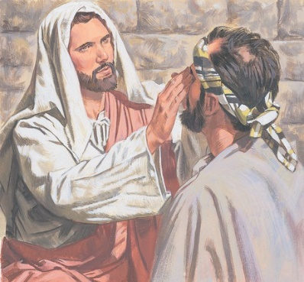
Name _________________ Date _____________
Blind Bartimaeus
Complete the paragraph by filling in the blanks with the correct words from the word bank at the bottom of the story.
As _______________ and his disciples, together with a large crowd, were leaving the city, a _________ man, Bartimaeus, was sitting by the roadside _____________. When he heard that it was Jesus of Nazareth, he began to _____________, “Jesus, Son of David, have ____________ on me!”

Many told him to be ____________, but he shouted all the more, “Son of David, have mercy on me!”

“What do you want me to do for you?” Jesus asked him.

The blind man said, “Rabbi, I want to ____________”

“Go,“ said Jesus. “Your _____________ has __________ you.” Immediately he received his ________________ and followed Jesus along the road.
begging, faith, Jesus, quiet, shout
blind, healed, mercy, see, sight

