Swallows
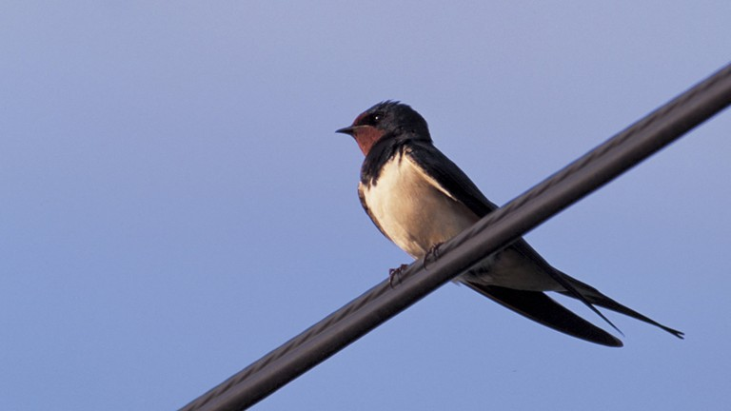
In early May swallows make their home in open countryside, often near water, where they nest in rural buildings such as barns. The female lays three to six eggs. By July her first brood of young has usually left the nest and flown away. The parents may raise a second or even third brood.
By early September most swallows are preparing to migrate. They flutter about restlessly and often gather on telegraph wires. Most leave the UK during September, with early broods of youngsters being the first to go. But a few stragglers may hang around into October.
The return journey to Africa takes about six weeks. Swallows from different parts of Europe fly to different destinations. Ours end up in the very south. They travel down through western France and eastern Spain into Morocco, before crossing the Sahara desert and the Congo rainforest – finally reaching South Africa.
Swallows migrate during daylight, flying quite low and covering about 320km each day. At night they roost in huge flocks. Since swallows feed entirely on flying insects, they don’t need to fatten up before leaving, but can snap up their food along the way. Nonetheless, many die of starvation. If they survive they can live for up to sixteen years.
Swifts
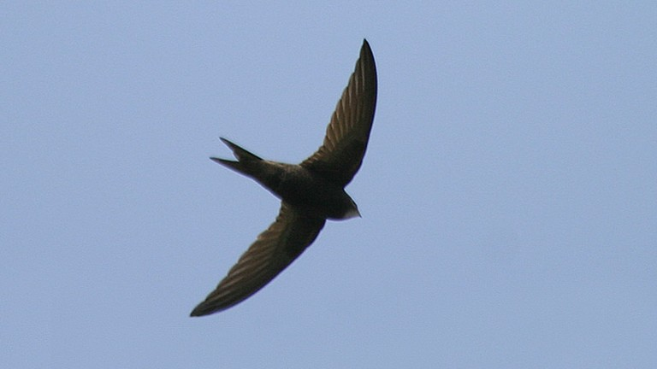
Swifts need warm weather to provide a constant supply of flying insects, so they spend only about three months in the UK each year. They arrive from central Africa in early May and make their nests of straw and saliva in church towers and other tall buildings.
Young swifts remain in the nest for 37–56 days, depending on the weather conditions. If it gets too cold, they fall into a sleepy state called torpor – a bit like hibernation – during which they don’t feed until conditions improve. Youngsters are independent as soon as they leave the nest, and set out immediately on migration.
Swifts start their return journey in mid July, before nights become too cool. They can’t roost overnight during the journey, like swallows do, so they travel quickly. One young swift that left its UK nest on 31 July, was found in Madrid (Spain) on 3 August.
By mid-August, most swifts have reached central Africa. They do not spend the winter in one place, but travel around according to food supplies and weather conditions. Swifts can live up to 21 years, so one individual may fly over one million kilometres during its lifetime.

