


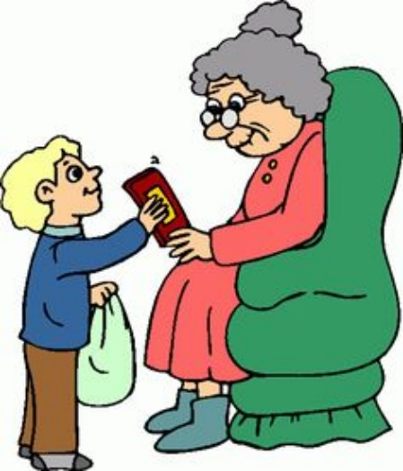
Rotary Club of Ballymena

The old
and less fortunate need

YOUR help
this Christmas

Please put
some items
into the
Rotary
Hamper box

The old
and less fortunate need

YOUR help
this Christmas

Please put
some items
into the
Rotary
Hamper box

The old
and less fortunate need

YOUR help
this Christmas

