CASE FOR CHANGE – Supporting Information
SUMMARY/OVERVIEW
AREA PLANNING DISTRICT | Locality North
DP NUMBER

PROPOSER | Board of Governors of Braidside Integrated Primary School  Dale Burnett (Chairperson)  89 Frys Road  Ballymena  County Antim  BT43 7EN  Tel: 02825 647899  Contact: Julie McAuley, Principal  Email: info@braidsideintegratedps.ballymena.ni.sch.uk
SCHOOL NAME | Braidside Integrated Primary School and Nursery Unit
SCHOOL REFERENCE | 306-6551
TYPE | Primary
MANAGEMENT | Grant Maintained Integrated
DP PUBLICATION TYPE | Date: __________________
PROPOSAL | The Board of Governors of Braidside Integrated Primary School proposes to establish an afternoon nursery session for 26 children (Part-time) within the existing nursery unit with effect from 1 September 2025 or as soon as possible thereafter.

STATUTORY CONSULTATION
EDUCATION AUTHORITY COMMENTARY ON PRE-PUBLICATION STATUTORY CONSULTATION
PROPOSER  Provide detail of consultation with the Board of Governors, teachers and parents of the affected school(s) – dates of meetings / letters. Good practice suggests all staff (including non-teaching) should be consulted as well as pupils.  Summary and assessment of views received – how were these considered before publication of the DP? | TO BE COMPLETED  Governors:  Over the last number of years, the Board of Governors have discussed the future development of the Nursery and Primary School regularly at meetings. Integrated Education and the Nursery progress have been a standing item on the agenda during the regular Board meetings throughout the 23-24 academic year.  Governors have been consulted on their views during the following meetings:  06.12.22 12.10.23  14.03.23 06.02.24  09.05.23 12.03.24  10.10.23 09.04.24  14.11.23 14.05.24  At all stages the Board of Governors have agreed and been in support of the development proposal for the Nursery. There is consensus that in order to further expand the integrated provision at Braidside IPNS, an afternoon session would be a positive development.  Staff (Teaching and Non-Teaching):  As with the Board of Governors, the staff at Braidside have been consulted too. This has been discussed at staff meetings and information shared in letters.  Staff meetings took place in January 2023 (23.03.23), August 2023 Baker Day (31.08.23) and again at a staff meeting on 17.10.23.  Responses from staff have demonstrated support for the Development Proposal as it will allow our Nursery to meet the demand for places in an Integrated setting, and will facilitate parental choice and sustain Integrated education in our area.  Parents:  A further survey of parents, pupils and the wider school community was undertaken from 22nd Nov until 22nd December 2023.  There was an overwhelming response to this consultation. The main concerns were from parents with younger children still to apply for places, with many worried about the lack of available spaces in our current single Nursery Unit.  The views of the Governors, Staff and parents are detailed within the document and were unanimously in favour of taking forward a Development Proposal for an additional 26 part-time nursery places at their Grant Maintained Integrated primary school.  The consultation for this proposal has continued throughout 2024 with informal and ad hoc conversations with parents, staff and governors. All of these stakeholders have continued to express support throughout this period.  In total, the consultation period for this proposal has run from January 2023 to present.

CONFIRMATION BY THE PROPOSER | I confirm that the school Board of Governors, staff and parents of pupils were consulted (see dates above) and Equality Screening of the proposal has been carried out and the statutory requirements of the Rural Needs Act (NI) 2016 (where appropriate have been considered.  Name: 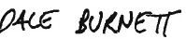  Office held: Chair to The Board of Governors  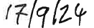    Signed: Date:

ASSOCIATED PROPOSALS

The following is to be completed by the EA and signed off by it.
EDUCATION AUTHORITY COMMENTARY ON PRE-PUBLICATION STATUTORY CONSULTATION
The Education Authority | I confirm that the schools which the EA consider might be impacted by this proposal were consulted on:  Name:  Office held:  Signed: Date:
Provide detail of consultation with schools that may, in the EA’s opinion, be affected by the proposal – list of schools, dates of letters issued to schools/meetings

Summary of views received (number of responses, recurring themes, petitions, community support or opposition)

Responses/Assurances in respect of issues raised during consultation
Dates of EA meetings e.g. Education Committee Board etc.

Details of issues raised by members of EA Board

1 Introduction
The purpose of this Case for Change is to support the Development Proposal submitted by the Board of Governors for Braidside Integrated Primary and Nursery School (Braidside IPNS), which proposes that an afternoon nursery session for 26 children (part-time) is established within the existing nursery unit, with effect from 1 September 2025 or as soon as possible thereafter.
This Case for Change will explain in detail the rationale behind this proposal, considering the best needs of the children and families attending Braidside IPNS and within the local area. It will provide detailed and sufficient evidence, including background information and statistics, to support this proposal, and will place itself firmly within the context of relevant policy.
Ultimately, this proposal and its approval would help to ensure the sustainability of Braidside IPNS, and in turn Integrated provision within the Ballymena area generally in line with the Integrated Education Act (NI) 2022. Furthermore, it would be a response to the identified demand from local parents, who have been consulted throughout this process, and would facilitate the Department to provide Integrated pre-school education to a greater number of children and young people in the Ballymena area.

2 Background

2.1 Description of school
When Braidside IPNS was first founded, it was amidst much scepticism that an Integrated school in Ballymena could attract enough pupils to remain open. Now, more than thirty years later, Braidside is not only still standing, but has undergone huge growth. From its makeshift beginnings in a former factory, the primary school now has its own site and purpose-built accommodation. Pupil numbers have also soared from the fifty students that originally made up the school to more than three hundred.

Over the years, despite other changes, Braidside has remained steadfastly committed to the principles that inspired its foundation. Primarily, this is a belief that Integrated Education provides children with the best start in life. Braidside strives to maintain 30% of each the two main Christian traditions in Northern Ireland, Catholic and Protestant, with the remainder of the pupils coming from other backgrounds. It is the express aim of the school to bring the two main cultures of Northern Ireland together to help build a shared future. Braidside IPNS also adheres to other important principles such as its commitment to bringing out the full potential of every child that passes through its doors.

It was in 1988 that campaigning to open an Integrated primary school first began in Ballymena. With the support of the Council for Integrated Education (NICIE), the founding parents were able to register enough students to open the school the following year. In September 1989, Braidside finally opened with a nursery and two primary classes and enjoyed a successful first year. At the end of it, the school received a great boost when it was recognised by the Department of Education (DE) and was given funding, although this did not extend to the nursery, which continued to be run as a charity until the late 1990s. The nursery unit was not given Grant Maintained Integrated (GMI) status until September 1999, after the prohibition on Integrated nurseries that was contained in the 1989 Education Reform Order was finally repealed by the 1998 Education Order. In 1992, the primary school finally received its own site. A piece of land on Frys Road was purchased and temporary prefabricated buildings were put in place over the summer to be used as classrooms during the new school year. Having been in mobile accommodation for more than 20 years, Braidside moved into the new purpose-built school in August 2020.

The focus in Braidside is very much on having every child achieve their full potential. The school aims to cater for children of every ability and has support in place for children with special educational needs. The current teaching staff consists of the principal, 10 full-time teachers and 3 part-time/job-share teachers. The classroom assistants, secretary, building supervisor, cleaners, supervisory assistants, and meals staff complete the full staff team.

The existing nursery unit has 26 part-time places. Admissions and applications, detailed in Section 3.1, demonstrate a steady & continuous demand for nursery provision in this Integrated setting and continued over-subscription, year on year.

2.2 Current Accommodation
The school accommodation consists of 14 classrooms, a Learning Support room, teaching courtyard, open library space, KS1 and 2 resources spaces, assembly/dining/PE hall, admin block (including Secretary/Principal/VP & Bursar’s offices) as well as separate nursery accommodation consisting of a classroom, outdoor space, quiet room, cloakroom, staff room and small kitchen.

2.3 Characteristics of the Area

2.3.1 School location
The school is situated on Frys Road in Ballymena, on a main arterial route to the town itself, with large housing developments close by, including Dunclug and Dunfane, as well as new housing on the Frys Road itself.
Map 1: Location of Braidside Integrated Primary and Nursery School
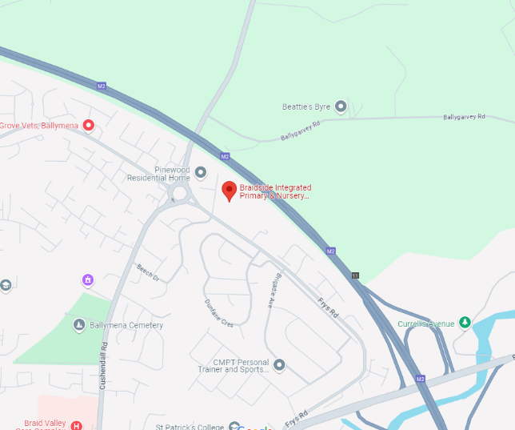
Source: Google Maps

2.3.2 District Electoral Area (DEA)
Braidside IPNS is in the Ballymena DEA, found within the Local Government District of Mid and East Antrim.

On Census Day 21st March 2021, in Ballymena DEA, considering the resident population:
- 94% were from the white (including Irish Traveller) ethnic group;
- 32% belong to or were brought up in the Catholic religion, 55% belong to or were brought up in a ‘Protestant and Other Christian (including Christian related)' religion, and 13% belong to or were brought up in Other or No Religion; and
- 40% indicated that they had a British national identity, 11% had an Irish national identity and 19% had a Northern Irish national identity*.
*Respondents could indicate more than one national identity

On Census Day 21st March, considering the population aged 16 years old and over:
- 37% had no or low (Level 1*) qualifications.
- 25% had a degree or higher qualification.
*Level 1 is 1-4 O Levels/CSE/GCSE (any grades) or equivalent

According to the 2021 census, the level of education across the whole of Northern Ireland for no or low qualifications is 29%, whilst those having Level 4 qualifications or above is 32%. By contrast, in Ballymena DEA, no or low qualifications is 37%, whilst those with Level 4 qualifications or above is 25%. Therefore, it is clear to see that Ballymena’s levels of qualification are significantly lower than that of the Northern Ireland average.

The ‘Fair Start’ report, published in May 2021 stated:
“Ensuring all children get a fair start, will lead to more equitable outcomes for all children, families and communities. The benefits of effective early intervention will be in terms of physical and mental wellbeing, educational attainment and longer-term employment prospects.

2.3.3 Ward
Whilst the children enrolled at Braidside IPNS come from a range of wards, the school is located in the Braidwater ward. On Census Day 21st March 2021, in Braidwater ward, considering the resident population:
- 97.78% were from the white (including Irish Traveller) ethnic group;
- 64% belong to or were brought up in the Catholic religion, 26.29% belong to or were brought up in a ‘Protestant and Other Christian (including Christian related)' religion, and 9.71% belong to or were brought up in Other or No Religion; and
- 25.18% indicated that they had a British national identity, 24.56% had an Irish national identity and 23% had a Northern Irish national identity*.
*Respondents could indicate more than one national identity
On Census Day 21st March, considering the population aged 16 years old and over:
- 31.89% had no or low (Level 1*) qualifications.
- 27.63% had a degree or higher qualification.
*Level 1 is 1-4 O Levels/CSE/GCSE (any grades) or equivalent

Again, the statistics indicate that that educational attainment in this area is lower than the national average, reemphasising the importance of the statements made in the ‘Fair Start’ report.

2.3.4 Deprivation
The Northern Ireland Multiple Deprivation Measures (NIMDM) 2017 provide information on seven types of deprivation and an overall measure of multiple deprivation for small areas. When this was introduced in 2017, it was measured by the 890 Super Output Areas (SOAs). These were ordered from the most deprived to the least deprived on each type of deprivation and assigned a rank, with the most deprived SOA being ranked 1 and the least deprived being ranked 890. Braidside Primary School is in the Summerfield SOA.
Table 1 below shows that Summerfield ranks in the top 20% of the least deprived areas of Northern Ireland, with an NIMDM rank of 734.
Table 1: Northern Ireland Multiple Deprivation Measures 2017 for the Summerfield SOA.
Rank
Summerfield
Multiple Deprivation Measure | 734
Income Deprivation | 846
Employment Deprivation | 581
Health Deprivation and Disability Deprivation | 579
Education Skills and Training Deprivation | 543
Access to Services Deprivation | 452
Living Environment | 835
Crime and Disorder | 582
Income Deprivation Affecting Children | 819
Income Deprivation Affecting Older People | 688

Source: NISRA Data Portal (Accessed July 2023)

2.4 Pupil Distribution
Map 2: Postcodes of nursery pupils attending Braidside IPNS, 2023.
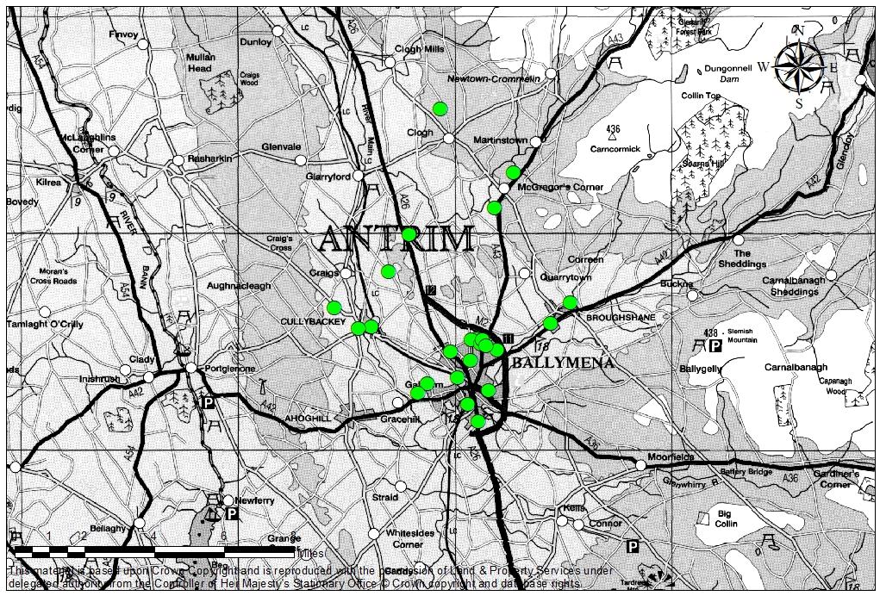

Source: School SIMS data and DE Statistics section
Map 3: Postcodes of P1-7 pupils attending Braidside IPNS, 2023.
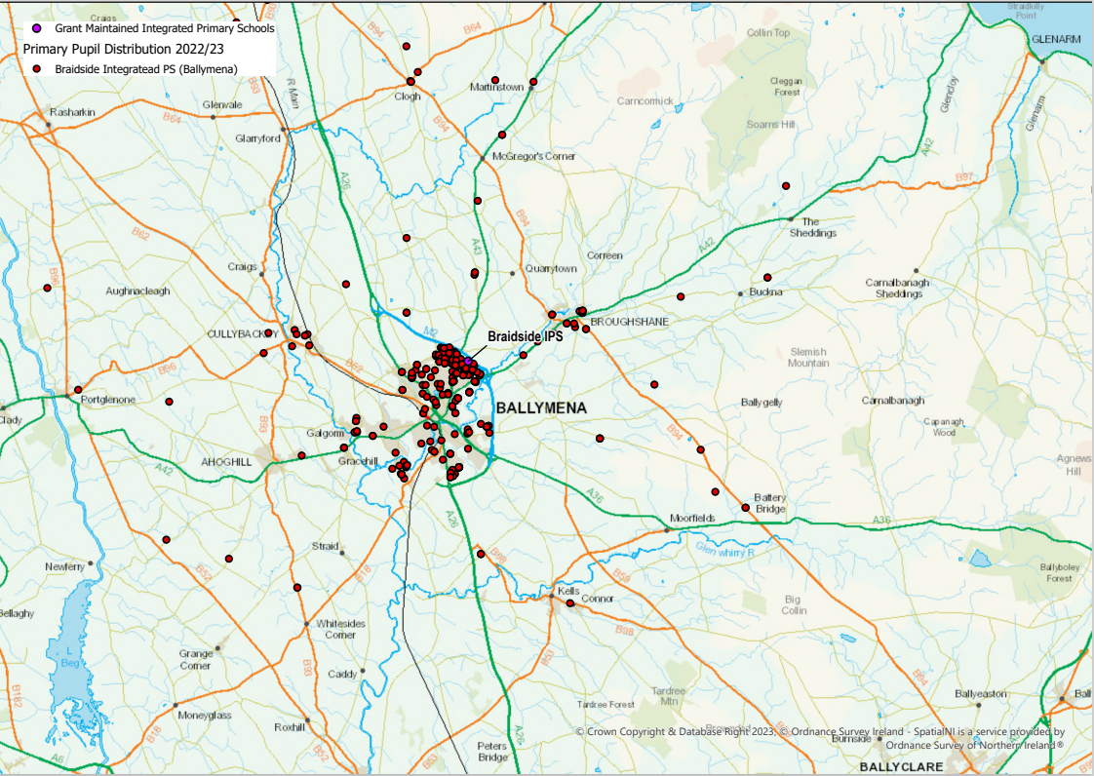

Source: Education Authority Area Planning (2023)
Maps 2 and 3 demonstrate that Braidside IPNS draws pupils who reside beyond the Ballymena area and within broader County Antrim. Braidside IPNS also serves the rural hinterland of this district. This applies to both the Year 1 to 7 cohort and to nursery children, as the school is the only Grant Maintained Integrated provider with nursery provision in the Mid Antrim area at present.
This is represented in Map 4 below, which locates other Integrated schools in Mid and East Antrim, alongside the Year 1 to 7 pupil distribution of Braidside IPNS, as well as by Table 2, which measures the distance between Braidside IPNS and nearby Integrated schools. Corran IPS, Acorn IPS and Round Tower IPS are the nearest Integrated schools with nursery provision, with Round Tower being the closest, being over 10 miles away as the crow flies. It is evident, therefore, that given the distances highlighted in Map 4 and Table 2, these settings would not be viable travelling options for families of pre-school age children, highlighting Braidside IPNS’s need for additional provision.
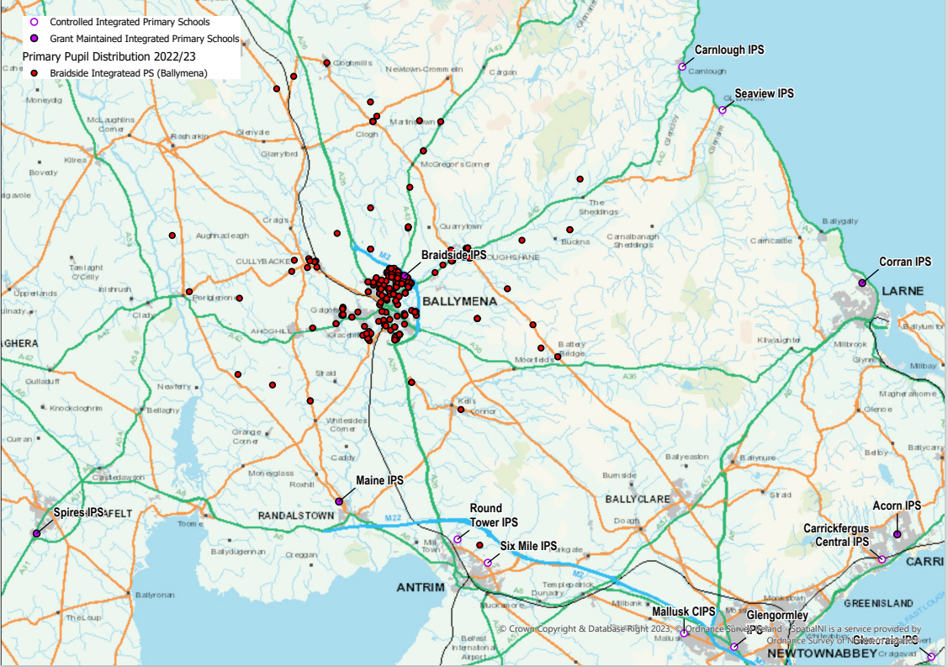
Map 4: Locations of other Integrated primary schools in Mid and East Antrim, alongside Year 1-7 pupil distribution of Braidside IPNS

Source: Education Authority Area Planning (2023)
Table 2: Distance from Braidside IPNS to the next nearest Integrated provision by two methods – as the crow flies and driving distance.

Distance from Braidside IPNS BT43 7EN to | Distance as crow flies (miles) | Distance to drive (miles)
Acorn IPS, BT38 7JL | 21.224 | 25.013
Corran IPS BT40 1TE | 17.413 | 20.989
Round Tower IPS BT41 2TH | 10.115 | 13.017
Ballycastle IPS BT54 6BJ | 22.464 | 27.129
Mill Strand IPS BT56 8EW | 27.349 | 31.263
Source: Freemaptools.com

3 Supporting Information

3.1 Enrolments, Applications and Admissions

3.1.1 Enrolments
Braidside IPNS’s admissions number is 58, and the school’s overall enrolment number is currently __322_.
At present, the school has 26 part-time Nursery places.

Table 5: Pattern of Enrolments at Braidside IPNS since 2019
Year | Enr No. | 2024/25 | 2023/24 | 2022/23 | 2021/22 | 2020/21 | 2019/20
Enrolment | 348 | 322 | 319 | 321 | 305 | 305 | 290
Nursery Unit | 26 | 26 | 26 | 26 | 25 | 26 | 26
P1 |  | 39 | 42 | 42 | 50 | 41 | 42
P2 |  | 44 | 40 | 50 | 43 | 42 | 24
P3 |  | 42 | 50 | 45 | 43 | 28 | 41
P4 |  | 56 | 45 | 42 | 27 | 44 | 39
P5 |  | 44 | 42 | 27 | 44 | 42 | 31
P6 |  | 43 | 27 | 46 | 42 | 32 | 48
P7 |  | 28 | 47 | 43 | 31 | 50 | 39
Source: DE Schools Plus and school
Table 5 demonstrates that there are available places spread across each year group within the school, from Year 1 to Year 7. This contrasts with the annually oversubscribed nursery unit. It is our view that these available places are a result of the school not having a two-form entry nursery unit to match the two-form entry primary school. The school knows from talking to local parents that if parents are unable to access nursery provision in the Integrated setting, and their child becomes established within another school, there is increased difficulty and unlikelihood of parents moving their child at the Year 1 stage.
Approval of this proposal would provide additional places within the nursery which would in turn increase the number of children moving into Year 1, solidifying the sustainability of Braidside IPNS and in turn Integrated primary provision within the Ballymena area.

3.1.2 Admissions
Table 6: Applications (including underage applications) and Admissions for part time places in Braidside Nursery Unit since 2017
Year | Total Admissions | 1st Preferences | Total Applications | Level of under/over subscription (uss/oss)
2017/18 | 24 | 21 | 24 | 8% uss
2018/19 | 26 | 35 | 39 | 50% oss
2019/20 | 27 | 40 | 62 | 139% oss
2020/21 | 26 | 45 | 63 | 142% oss
2021/22 | 26 | 44 | 58 | 123% oss
2022/23 | 26 | 53 | 71 | 173% oss
2023/24 | 26 | 43 | 56 | 115% oss
2024/25 | 26 | 38 | 63 | 142% oss
Source: EA Figures as at conclusion of Admission process each June, with the exception of the 2017/18 figures when the information was provided in October 2017
Table 6 above demonstrates that the nursery unit within Braidside IPNS has been oversubscribed for the past six years. The total applications column shows its capacity to fill a second session. Furthermore, it is evident that this could have been filled in the year 2022/23 based on first preferences alone. It should be noted that in 2023/24, whilst the nursery unit remained oversubscribed, numbers were likely impacted by the cyclical issue of the impact of heavy oversubscription in any given year resulting in a downturn the following year. There is a strong demonstration of parental demand for Integrated Education at the Nursery phase evidenced here, and it would be fair to assume that more places in the nursery unit would result in further demand and applications.
The mismatch between the admissions number of the school, which is 58, versus the capacity of the nursery unit, which is 26, is evidenced in Table 7 below. As the nursery unit is often heavily oversubscribed, the school is forced to turn away the unplaced children, which resultantly has a detrimental effect on the applications the following year to P1 and therefore on the overall enrolment and sustainability of the school.
Furthermore, the 26 children placed in the nursery unit are, in the main, siblings of children already enrolled in the primary school. This restriction means that it is often the case that no new families (those applying for their eldest child) can avail of a place in Integrated Education. Therefore, the current 26 part-time nursery provision is not encouraging or facilitating the development of Integrated Education in the Ballymena area, nor is it meeting the current parental demand for places in the nursery unit.
The level of over-subscription at the nursery level indicates that Braidside IPNS would easily be able to support a two-form entry nursery unit, which would in turn support the two-form entry Integrated primary school. Occasionally, Braidside IPNS has applied for an additional place using the temporary flexibility for a twin sibling. The current enrolment pattern has a detrimental effect on the long-term sustainability of Braidside IPNS as a two-form entry school.
To increase the size of the nursery unit to two form entry would fit with Section 5 of the Integrated Education Act 2022, as it would meet the demand for Integrated Education within the context of area planning and the overall sustainability of the school estate (Section 5 (b)).
Table 7: Braidside IPNS Year 1 Admissions September 2024 for those pupils attending the Braidside Nursery Unit
Total Nursery Unit Admissions Number | Pupils transferring from NU to Year 1 at BIPS in September 2024 | Total applications to Year 1 September 2024
26 | 22 | 40
Source: School
Of the pupils who attended the nursery unit during 2023/24, 84.6% applied for a Year 1 place for September 2024. This enabled for a smooth transition for both children and the families and further reflects the demand for Integrated provision.
It is worth noting that the school has received on-going requests for placements for underage pupils, outside of the EA admissions process, and this demand is not included in the figures above.

3.2 Integrated Education Act (NI) 2022

This section outlines how the school aligns to the legal definition of Integrated Education. The Integrated Education (NI) Act 2022 defines the meaning of Integrated Education as:
“Integrated Education” means the education together, in an Integrated school, of –
- those of different cultures and religious beliefs and of none, including reasonable numbers of both Protestant and Roman Catholic children or young persons;
- those who are experiencing socio-economic deprivation and those who are not; and
- those of different abilities
An “Integrated school” is a school which –
‘Intentionally supports, protects and advances an ethos of diversity, respect and understanding between those of different cultures and religious beliefs and of none, between those of different socio-economic backgrounds and between those of different abilities…’

Section 2 of the Integrated Education (NI) Act 2022 sets out the purpose of Integrated Education as the following:
The purpose of Integrated Education is –
- to deliver educational benefits to children and young persons;
- to promote awareness and appreciation of human rights;
- to promote equality of opportunity;
- to promote good relations; and
- to promote respect for identity, diversity and community cohesion.

3.2.1 Those of different culture and religious beliefs and those of none
In relation to Braidside IPNS, Appendix L demonstrates that most of the providers in the Ballymena area have school populations which are predominantly Protestant or Catholic designated children, with only two providers out of 17 showing a mix. This relates to 22/23, which is the most recent data available. In the mixed settings it is striking that there is a high percentage of those designating as Other Christian, non-Christian, no religion or unknown. This is also a feature of Braidside IPNS’s school figures (see below).

Table 8: Religious Balance in Braidside IPNS (including Nursery Unit) 2023-4

 | Protestant | Catholic | Other/Non-Christian/No Religion/Unknown
Braidside IPNS (School figure) | 59 | 104 | 156
Source: DE Schools Plus website

To show how Braidside IPNS is complying with the new definition of Integrated Education included in the Integrated Education Act (2022), a request was made to the DE statistical staff for a breakdown of the ‘Other’ category into its three constituents, which are:
- Other Christian;
- Non Christian; and
- No Religion/Unknown.

This resulted in Table 9 below, which shows that there is a growing number of people from different religious beliefs. This is in keeping with the new definition on Integrated Education.

Table 9: Religious breakdown Braidside IPNS for P1-7 by Number of Pupils, 2018/19 to 2024/25(Years 1-7)
Academic year | Protestant | Catholic | Other Christian | Other Religion | No religion | Total
2018/19 | 76 | 84 | 18 | 5 | 80 | 263
2019/20 | 73 | 87 | 16 | 8 | 80 | 264
2020/21 | 75 | 96 | 15 | 10 | 83 | 279
2021/22 | 69 | 89 | 14 | 10 | 98 | 280
2022/23 | 66 | 93 | 16 | 13 | 107 | 295
2023/24 | 59 | 95 | 12 | 14 | 113 | 293
2024/25 | 57 | 91 | 17 | 14 | 117 | 296
Source: Department of Education NI

Table 10: Religious breakdown by percentage for Braidside IPNS P1-7, 2018/19 to 2024/25, with new Protestant and other Christian category.
Academic year | Protestant and other Christian | Catholic | Other Religion | No Religion
2018/19 | 35.7 | 31.9 | 1.9 | 30.4
2019/20 | 33.7 | 33.0 | 3.0 | 30.3
2020/21 | 32.3 | 34.4 | 3.6 | 29.7
2021/22 | 29.6 | 31.8 | 3.6 | 35.0
2022/23 | 27.8 | 31.5 | 4.4 | 36.3
2023/24 | 24.2 | 32.4 | 4.8 | 38.6
2024/25 | 25.0 | 30.7 | 4.7 | 39.5
Source: Department of Education NI

The NICIE Statement of Principles encourages Integrated schools to aspire to a 40:40:20 balance (Catholic, Protestant and Other, respectively). In the case of Braidside IPNS, whilst its percentage of ‘No Religion’ is growing in common with many schools across Northern Ireland, and demonstrated in the 2021 Census, the remaining percentage allocated to Christian faiths is fairly equal. This demonstrates ‘reasonable numbers’ of Protestant and Catholic pupils, in adherence to the new definition written in the IE Act (2022). It is notable that the percentage of those of other faith backgrounds has more than doubled in the last five years.

Table 11: Religious breakdown Braidside IPNS Nursery Unit by Number of Pupils, 2018/19 to 2024/25
Academic year | Protestant | Catholic | Other Christian | Other Religion | No religion | Total
2018/19 | 6 | 11 | * | * | # | 26
2019/20 | 8 | 8 | * | * | # | 26
2020/21 | * | 10 | 0 | * | # | 26
2021/22 | * | 10 | * | * | 8 | 25
2022/23 | * | 8 | * | * | 12 | 26
2023/24 | 3 | 9 | 1 | 1 | 12 | 26
2024/25 | 4 | 7 | 1 | 1 | 13 | 26
Source: Department of Education NI

Table 12: Religious breakdown by percentage for Braidside IPNS Nursery Unit, 2018/19 to 2022/23, with new Protestant and other Christian category.
Academic year | Protestant and other Christian | Catholic | Other Religion | No Religion
2018/19 | 26.9 | 42.3 | * | #
2019/20 | 34.6 | 30.8 | * | #
2020/21 | 15.4 | 38.5 | * | #
2021/22 | 20.0 | 40.0 | * | #
2022/23 | 19.2 | 30.8 | * | #
2023/24 | 15.4 | 34.6 | * | #
2024/25 | 19.2 | 26.9 | * | #
Source: Department of Education NI

With regards to the nursery unit, Tables 11 and 12 use * to indicate where the numbers are 4 or less, and # for the remaining numbers. In a 26-place nursery unit, four children represent 15.4%, so the combination of ‘Other Christian’ and ‘Protestant’ enables a better understanding of the balance as it relates to the Northern Ireland Census. This enables some comparisons to be made with the Northern Ireland Census figures, which are useful in understanding the demographics of the area. It shows that in all years, reasonable numbers of Protestant and Catholic children are being represented within the nursery unit, however, increasingly it would appear that people are designating as ‘No Religion’. This is in mirrored with the primary school for pupils in P1-7.

Figure 1: Census Information for Ballymena DEA for Religion & Ethnicity
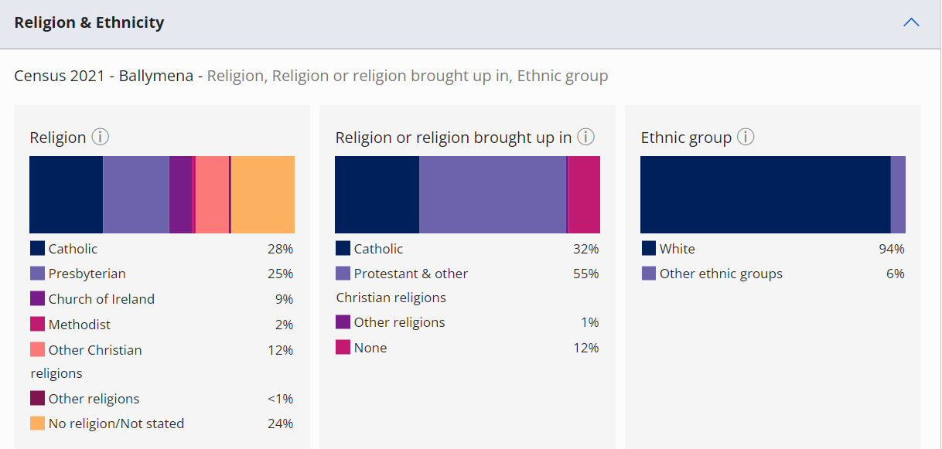
Source: NISRA Census Area Explorer

Braidside IPNS is achieving a balance that is in line with the legal definition of Integrated Education, given the religious balance within Ballymena DEA, as depicted above.

Table 13: Newcomer pupils in Braidside IPNS, 2018 - 2025
 | 2018/19 | 2019/20 | 2020/21 | 2021/22 | 2022/23 | 2023/24 | 2024/25
Newcomer pupils | 8 | 11 | 6 | 10 | 23 | 26 | 36
Percentage (%) | 2.8 | 3.8 | 2 | 3.3 | 7.2 | 8.2 | 11.1
Total pupils | 289 | 290 | 305 | 305 | 321 | 319 | 322
Source: DE Schools Plus
Braidside IPNS has also seen a significant rise in its newcomer population as demonstrated in Table 13. The 2022/23 figure, significantly higher than the preceding years, shows greater diversity within the student population, and is higher than the 2022/23 national average, which was 5%. This grew again the subsequent year, with 8.2% of pupils being newcomers.

Table 14: Ethnicity within Braidside IPNS, 2018 – 2025
 | 2018/19 | 2019/20 | 2020/21 | 2021/22 | 2022/23 | 2023/24 | 2024/25
White (excluding Irish Travellers) | 281 | 278 | 291 | 288 | 303 | 301 | 296
Percentage (%) | 97.2 | 95.9 | 95.4 | 94.4 | 94.4 | 94.4 | 91.9
Other | 8 | 12 | 14 | 17 | 18 | 18 | 26
Percentage (%) | 2.8 | 4.1 | 4.8 | 5.6 | 5.6 | 5.6 | 8.1
Total pupils | 289 | 290 | 305 | 305 | 321 | 319 | 322
Source: DE Schools Plus
The school’s diversity in ethnicity is reflected in Table 14. This is in keeping with the census figures for Ballymena DEA (Figure 1), showing consistency with the local area. Braidside has and continues to go above and beyond to intentionally represent diverse cultures and religious beliefs within the school. To deliver Religious Education (RE) currently in the school, parents have the opportunity to select their preferred denominational RE option for their children, whether Protestant RE, Catholic RE or a Social and Moral option. The curriculum, including Personal Development and Mutual Understanding (PDMU) as well as the work done as part of the ‘Take 5’ approach to wellbeing (Wellbeing Wednesday) enables the school to deliver a wide range of lessons related to religion and culture. During the year, the school holds special assemblies to mark and celebrate Harvest, Christmas and Easter. At the same time, there is recognition and celebration of those children and families in the school who participate in sacramental preparation and the ceremonies of Reconciliation, First Communion and Confirmation. For those children celebrating First Communion, many members of the school community attended this special occasion, including staff and children in the class who are not members of the Catholic faith. Through the social and moral option as well as PDMU and general RE lessons, children are introduced to a wide range of religious faiths and beliefs and will recognise in class, particular festivals through the school year, noting Diwali, Ramadan and Eid, as there are Muslim and Hindu families in the school. There have been a range of visitors to school over many years, who have participated in assemblies, sharing information and exposing children to religious elements and ideas.

The school also celebrates St Patrick’s Day each year with activities, lessons and non-uniform events. Additionally, during the last couple of years, it also celebrated Queen Elizabeth II 70th Jubilee with a full day of school activities, which all cultures in the school enjoyed, and which was supported by staff and the wider school community. This was also the case following the Coronation of King Charles III.

Furthermore, during each school year, through assemblies and lessons, the school shares with the children what it means to be in an Integrated school, what makes it special, recognising the differing cultures and religious beliefs in the school and respect for all. To support this, the school will participate in Integrated Education month activities delivering a range of lessons to the children on a variety of themes.

The school achieved the Excellence in Integrated Education Award in 2011 and have recently appointed a new coordinator for RE and the Integrated Ethos, as it begins the journey and works towards attaining this award again. As a part of this, staff and governors have recently participated in workshops exploring the Integrated ethos and anti-bias training, facilitated by NICIE. Additionally, in beginning work on the delivery of RE in school, consultations have taken place with teaching staff and parents, including a parents’ forum meeting, to allow all members of the community to reflect and consider RE within Braidside IPNS.

3.2.2 Those who are experiencing socio-economic deprivation and those who are not
Braidside IPNS’s Free School Meals (FSM) sits at 38.9%, which is considerably higher than the 27.7% in Primary Schools across Northern Ireland on average in the year 2022/23, the most recently available statistics released by DE. This is represented in Table 15. This evidences that the school is meeting the new definition of Integrated Education given in the Integrated Education Act (2022), which states that Integrated schools must provide education for ‘those who are experiencing socio-economic deprivation and those who are not’.
Table 15: Pupils taking Free School Meals (FSM) at Braidside IPNS, 2018/19 – 2024/25
 | 2018/19 | 2019/20 | 2020/21 | 2021/22 | 2022/23 | 2023/24 | 2024/25
Pupils taking free school meals | 105 | 95 | 106 | 121 | 125 | 124 | 108
Percentage | 36.3 | 32.8 | 34.8 | 39.7 | 38.9 | 38.9 | 36.5
Total pupils | 289 | 290 | 305 | 305 | 321 | 319 | 322
Source: DE Schools Plus
As a result of the high level of pupils taking FSM, Braidside IPNS receives Extended Schools Funding which has allowed the school to put various activities in place for those children who would be considered vulnerable and/or requiring additional support. This would include a morning reading club, Lego play group, sporting activities and a school counselling service. These activities benefit children who are experiencing socio-economic deprivation, those who are on the Special Education Need register, as well as those who are not. For newcomer children the school provides withdrawal literacy support sessions to assist them in with their language skills and the transition to a new school and country.
In the last number of years, Braidside IPNS has held a used uniform event at the end of the school year and any uniform left is donated to Mid and East Antrim Council for their uniform exchange.

3.2.3 Those of different abilities
In 2023/24, 83 of the 324 children are on the Code of Practice (25.6%), 10 of whom are statemented. This is demonstrated in Table 16.

Table 16: SEN Pupils at Braidside IPNS, 2018/19 – 2024/25
 | 2018/19 | 2019/20 | 2020/21 | 2021/22 | 2022/23 | 2023/24 | 2024/25
Pupils with SEN – non-statement | 67 | 63 | 58 | 34 | 59 | 74 | 64
Pupils with SEN – statement | 6 | 6 | 8 | 6 | 6 | 9 | 13
Total pupils | 289 | 290 | 305 | 305 | 321 | 319 | 322
Source: DE Schools Plus
The significant number of children on the SEN register covering a wide range of needs, including literacy, numeracy, cognition, behaviour, sensory needs, moderate learning difficulties, communication and social difficulties, autism spectrum disorder and dyslexia.
The school provides small group withdrawal support for those children with literacy needs in addition to a morning reading club which further supports the development of literacy skills. For those children with behaviour and emotional needs, as well as Autism Spectrum Disorder, the school has worked hard to upskill staff (teaching and non-teaching) on the use of various strategies to employ in the classroom setting. The staff incorporates differentiated teaching as well as interventions which use sensory and calming resources. Calm tents are available in a multi-purpose room for those children who require this intervention. The school works alongside a range of outside agencies including literacy support, behaviour support, the Autism Advisory and Intervention Service (AAIS), RISE as well as Speech and Language Service and Special Education Needs Inclusion Service (SENIS) to support the children at school. Furthermore, for children with medical needs (diabetes and other specific medical issues) staff have participated in appropriate training to facilitate assisting children to manage throughout the school day, ensuring their safety and access to the full curriculum.
The annual Primary Test in English (PTE) and Primary Test in Mathematics (PTM) outcomes demonstrate clearly that Braidside is working with children with a wide range of abilities. At Braidside IPNS, our staff also support children with other abilities and interests. The school provides instrumental tuition from Primary 4 upwards and have also facilitated singing lessons through musical theatre with an outside tutor. There is a school choir which children can participate in. In relation to sport, the school provides opportunities for the children to participate in various multi-sport sessions during the school year, as well as the Healthy Kidz initiative which has been in operation for the last 18 months. Cycling proficiency is also offered during the summer term.
Braidside IPNS has achieved the gold levels award in the Sustrans Active Schools programme and the school enjoys a range of events and activities to promote this throughout the school year. Furthermore, Braidside IPNS is recognised as a ‘Take 5’ School, having achieved Level 1 in June 2023 and is now working towards Level 2. In June 2023 the school achieved the ECO schools flag and has an active and engaged Eco Committee, comprised of children from across the school and supported by a key teacher.

3.2.4 Overall
The above clearly indicates Braidside IPNS’s commitment to fulfilling the new definition of Integrated Education, in accordance with the Integrated Education (NI) Act 2022. The school recognises the importance of striving for diversity and inclusive practice and will continue to strive for this in an intentional way in future. Provision of an additional Nursery class, and thus approval of this proposal, would enable more children and young people within the vicinity to avail of this, fulfilling DE’s duty “to encourage, facilitate and support” Integrated Education.

4 Sustainability Assessment

4.1 Quality Educational Experience
Braidside IPNS was inspected by The Education and Training Inspectorate (ETI) in January 2017 (involving Action Short of Strike).
The importance of additional nursery provision at the school cannot be overstated, particularly regarding educational outcomes. Braidside IPNS currently has ____108_ of pupils in receipt of Free School Meals and ___77__ of its pupils registered with Special Educational needs, including __13_ with full Statements. The provision of 26 additional nursery places at Braidside IPNS would enable the school to ensure that all pupils entering Year 1 the following year would have had access to pre-school provision in Braidside IPNS. This would help with the early identification of needs and intervention, supporting the educational outcomes for the pupils concerned and assisting with smoother transition to the primary school phase.

4.2 Stable Enrolment Trends
Table 5 in Section 4.1.1 shows the enrolment pattern over several years. The school has dual intake into Year 1, and the school would be offering the children the best possible start by having a dual nursery unit session to provide that seamless transition into Year 1. The Board of Governors of Braidside IPNS believe that the existing provision at the school, in conjunction with the proposed future development highlighted in this development proposal, will ensure compliance with The Department of Education’s Sustainable Schools Policy.

The Board of Governors believe Ministerial approval for an additional afternoon nursery session to be established in the existing unit at Braidside IPNS, would be a welcome addition to the provision of Integrated Education in County Antrim. The Board of Governors is not currently meeting parental demand for places in the Integrated nursery setting.
Having a double class intake in Year 1 and having 26 Part-time places in the nursery unit causes a conundrum in that most years the nursery unit is often heavily over-subscribed but because the children cannot be accommodated this does not translate into P1 enrolments. The school has recently benefited from a new build which will facilitate the growth in the primary school, yet they cannot offer nursery unit places in the afternoons to match the double intake in the primary school. Therefore, the current 26 part-time nursery provision is not encouraging or facilitating the development of Integrated Education in Ballymena.

4.3 Sound Financial Position
The Principal is responsible for the day to day running of school finances and is supported by the Board of Governors to ensure there is prudent financial management. Governors consider school finances carefully during regular meetings and through the scrutiny of finance reports. A three-year financial plan is developed and reviewed regularly to maintain the high standards within the school.

In recent times, Braidside IPNS, like many schools across Northern Ireland, has been experiencing extreme pressures on its financial position. It is our view that this is more related to the funding crisis in the system, rather than a reflection of our ability to be financially astute. As a result of pressures and because of our inability to operate in a deficit without bank overdraft facilities (as a Grant Maintained Integrated school), we sought an emergency grant of £48,062 in January 2024, which enabled us to finish the year with a zero balance.

It is worth noting that an additional 26 nursery places can be accommodated without the need for any investment in accommodation, nor would there be any significant associated staffing costs or displacement of staff.

4.4 Strong Leadership and Management
Braidside IPNS has a strong leadership team led by the Board of Governors, Principal and Vice Principal. The school principal has engaged in the First Time Principals provision through the EA, acting as a mentor for a new principal and giving a talk to a new cohort at the start of the academic year. She participates in the local primary principals’ association as well as the Integrated principals’ forum, facilitated by NICIE. The principal participates in a wide range of continuing professional development courses including “Leadership Matters” a leadership programme offered by the EA, as well as the EA Coaching programme for Principals. The Vice principal participates in the vice principal’s forum, facilitated by NICIE.

The Board of Governors operate under the terms of the Scheme of Management for GMI schools. The Board of Governors is the employing authority for all staff in the school. Governors take their role very seriously and have invested time to avail of training opportunities. They meet regularly, generally once each month, and are aware of all aspects of the school, including the day to day running matters and operation of the school. This was most evident recently having come through the new build project. They provide much support for the principal and aim to be fully involved in the life of the school.

The Principal and Vice Principal are also supported by our dedicated team of key stage coordinators and senior leaders.

4.5 Accessibility
Braidside IPNS is located on the periphery of Ballymena town centre, which provides ease of access for all its present pupils. It is on a main arterial route in Ballymena and is also easily accessible to future pupils travelling from areas outside the current immediate catchment area. A number of families travel to school by bus, with two transport routes supporting pupils and families to access Integrated Education.

4.6 Community Links
Braidside IPNS has strong links with the local and wider community.
- We participated in The Shared Education Programme with Buick Memorial Primary School in Cullybackey.
- We host information sessions for local and regional providers e.g. NSPCC, Family Hub.
- We host students from Ulster University, Edgehill College, St Mary’s University College and Stranmillis as well as placement students from the Northern Regional College (NRC) and local post-primary schools.
- We support local and global charities.
- We have links with All Saints’/ Kirkinriola Parish and the local maintained primary schools in relation to sacramental preparation.
- Ministers from local churches visit the school for specific assemblies, including Harvest and Christmas.
- The school choir participate annually in Radio Cracker performances and visit Pinewood Residential Home adjacent to the school.
- We are committed to the Sustrans Active Travel programme, achieving the Gold Level Award with the whole school community participating in activities throughout the year, supported by Sustrans and the PSNI.
- We have well established links with the feeder pre-school settings and post-primary schools to which the pupils would normally transfer, attending STEM events, transition events as well as concerts and sporting opportunities.
- The school has worked in collaboration with a new afterschool provider, Little Munchkins, which will be launched this school year, following approval from the Northern Health and Social Care Trust. This provision will be available from 2-6pm daily.

5 Area Planning Impact

5.1 Overview
The Development Proposal for Braidside IPNS to increase the Nursery Unit from 26 to 52 part-time places is included in Operational Plan 1 2022-24. One of the stated aims of Area Planning is to create a network of sustainable schools, the addition of an afternoon nursery session would support the continued sustainability of Braidside IPNS as a sustainable school going into the future.

5.2 Population Trends
The tables below demonstrate the population projections and actual figures over a series of different time frames. The projections indicate a small decrease in the population, whereas the actual figures show a slight increase for the 0–15-year-old population, and a large increase in the 65 and older population over the decade 2010 to 2020.

Table 17: Figures for the Populations Projections for Northern Ireland and Mid and East Antrim for 0-15-year-olds

Area | Population Estimate  Mid-2018 | Population Estimate  Mid-2028 | Population  Change | % Population  Change
Mid and East  Antrim | 26,800 | 25,000 | -1,800 | -6.5
Northern  Ireland | 393,500 | 375,700 | -17,800 | -4.5

Table 17 above shows that across Northern Ireland there is an average drop in the population of 0–15-year-olds of 4.5% by 2028. The predicted drop in Mid and East Antrim is 1800 children which is a 6.5% drop in the population, which is slightly higher than the Northern Ireland average. Despite this, the demand for nursery places at Braidside IPNS remains high (see Table 6, Section 3.1.2).
Table 18: Children (aged 0-14) population and usual residential population by LGD Census 2021
Geography area | Population aged 0-14 | Population | Percentage of population aged 0-14
Mid & East Antrim | 24, 200 | 139, 000 | 17.4%
Northern Ireland | 365, 200 | 1, 903, 200 | 19.2%

Table 18 above shows that whilst the Northern Ireland Average for 0–14-year-olds is 19.2%, the Mid and East Antrim population of 0-14 year olds is slightly lower at 17.4%.

Table 19: Population changes in different age profiles for Mid and East Antrim from mid-year 2010 to mid-year 2020.
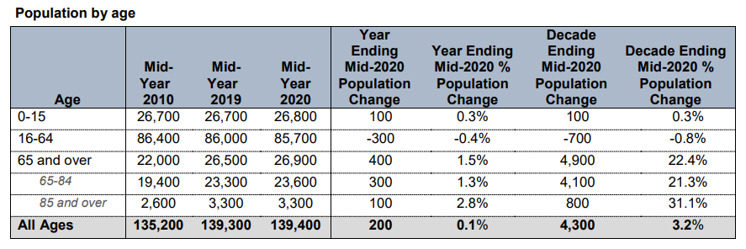
By comparison, the NISRA Population Estimates for Mid and East Antrim Local Government District at June 2020 shows that:
- Over the year ending mid-2020, the population increased by 200 people (0.1 per cent) to 139,400 (68,500 males, and 71,000 females).
- This can be attributed to natural growth of <50 people (i.e. more births than deaths), a net gain of <50 people due to migration, and a gain of 100 people due to other changes.
- The population aged 65 and over increased by 400 people (1.5 per cent) to 26,900. The working age population decreased by 300 people (0.4 per cent) to 85,700 people. The number of children increased by 100 people (0.3 per cent) to 26,800.
The fact that the number of 0–15 year-olds remains stable in this mid-year population estimate is interesting given that in Table 17, there is a projected drop in the population of 0-15 year olds by 6.5% in 2028 from 2018.

However, if one looks at the figures from the perspective of the pre-2014 Ballymena LGD, the population increased by 5.8% which is greater than the 5% population increase for the whole of Northern Ireland. The Ballymena LGD is a more accurate representation of the area Braidside IPNS draws its pupils from, as seen in Maps 2 and 3, and the data shown in Table 19 contrasts with the data given in Table 17, which suggests a drop in overall population.

If one compares the P1-P7 postcode map (Map 3) with areas shown in Maps 4 and 5, the map for the pre-2014 Ballymena LGD is a closer approximation to the distribution shown by Map 3. And thus, the slight increase in the population in the Ballymena LGD of 5.8% in 2020 as shown in Table 19 is a better representation of the relevant population for the area that Braidside IPNS draws from than the estimate of a 6.5% drop in population given in Table 17 for the Mid and East Antrim LGD.

Map 4: Map of the 2014 onwards Mid and East Antrim LGD area for comparison
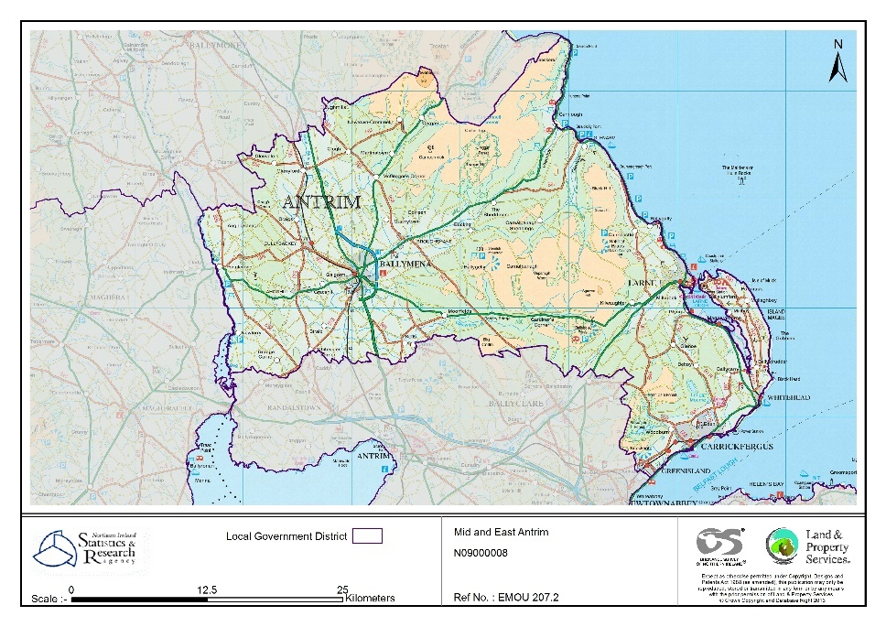
Source: Land & Property Services

Map 5: Map showing the pre-2014 Ballymena LGD area for comparison.
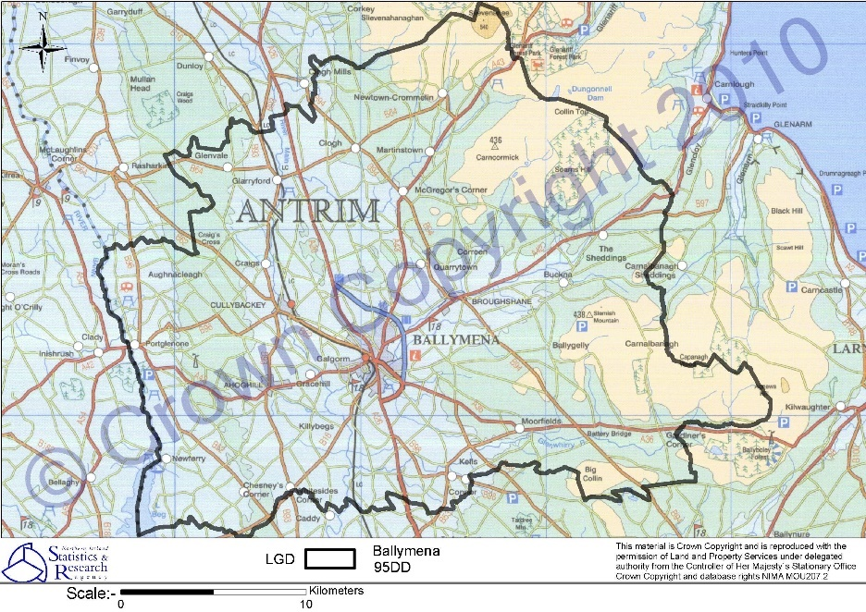
Source: https://www.ninis2.nisra.gov.uk/public/StaticMapViewer.aspx?geoCode=95DD&geoLevel=LGD

Table 20: Births by Academic year in the Wards (2018/19 – 2021/22) of the main Catchment Areas of Braidside IPNS
Ward | 2018/19 | 2019/20 | 2020/21 | 2021/22
Ardeevin | 41 | 32 | 49 | 44
Ballee and Harryville | 45 | 41 | 35 | 40
Ballykeel | 35 | 42 | 37 | 34
Braidwater | 24 | 30 | 31 | 30
Broughshane | 39 | 41 | 33 | 33
Castle Demesne | 68 | 64 | 58 | 55
Cullybackey | 40 | 23 | 32 | 28
Fair Green | 73 | 56 | 41 | 55
Galgorm | 29 | 33 | 35 | 25
Glenravel | 56 | 50 | 45 | 41
Glenwhirry | 25 | 31 | 25 | 27
Kirkinriola | 31 | 24 | 35 | 24
Park (Mid and East Antrim) | 19 | 17 | 19 | 21
Slemish | 30 | 31 | 36 | 33
Total | 555 | 515 | 511 | 490

Table 20 shows that the birth rates in the wards that act as feeders to Braidside IPNS has declined since 2018. Despite this, applications for pre-school places in the school have increased.

5.3 Housing

5.3.1 Housing Need in the Area
The Northern Ireland Housing Executive (NIHE) Commissioning Prospectus 2023-24 to 2025-26 provides a strategic overview of housing need and demand in Northern Ireland. The number of households in Mid and East Antrim is projected to increase by 2,726 from 56,337 to 59,063 over the ten years to 2029.

Table 21 below contains the projected number of social houses needed throughout Mid and East Antrim. As can be seen in the settlements of Ballymena Town, Broughshane and Cullybackey are expected to have an increased number of people requiring social housing by 2026, these are all settlements from which Braidside IPNS draw students. It is also worth noting that Mid and East Antrim LGD has a Housing Growth Indicator projected New Dwelling requirement of 5,400 by 2030.

Table 21: Projected (5 Year) Social Housing Need 2022-2027 for Settlements in Mid and East Antrim
Settlement | Total 5 Year Projection
Ballymena Town | 371
Carrickfergus Town | 152
Larne Town | 75
Whitehead | 42
Broughshane | 54
Carnlough | 18
Cullybackey | 34
Greenisland | 38
Glenravel | 12
Kells | 13
Portglenone | 23
Remaining Settlements * | 24
Total | 856
*Remaining Settlements include: Ahoghill, Ballycarry, Glenarm, Glynn and Islandmagee where need in each settlement is less than 10

5.3.2 Housing in the Local Area
The average house price in Mid and East Antrim has been increasing from £119,072 in 2015 to £163,185 in 2021. House prices are consistently lower than the Northern Ireland average over the years. The Northern Ireland average was £31,00 higher at £194,233 in 2021 ⁴. Local estate agents report that the number of sales and enquiries has increased

Over the last 5 years Ballymena has seen several new housing developments across the town. Those which are located within a few miles of the school include Carnwood on Carniny Road, Adair Manor on Ballymoney Road, Nursery Close, as well as Frys Meadow which is within half a mile of the school itself. Additionally, the previous school site, which is adjacent to our current school, has been acquired by a developer and is earmarked for housing accommodation too. The families that come to occupy these houses may well be attracted to attend Braidside IPS and NU.

5.4 Impact on Other Provision
In recent years, children have come from 17 different settings to attend Braidside IPNS at P1. Appendix F shows the feeder pre-school providers for Braidside Primary 1 for the past 4 years. The majority of the nursery unit children in Braidside transfer across and form the bulk of the pupils within P1. Of the remaining settings, the largest consistent contributors are Dunclug NS and Ballymena NS. Dunclug NS is oversubscribed, particularly for its full-time session, and therefore the impact of an additional session at Braidside IPNS NU is likely to be minimal on Dunclug NS.

The third largest contributor is Ballymena NS, situated 2.4 miles by car from Braidside IPNS. However, the numbers have not exceeded five children in the last four years. Ballymena NS is seeking to transform to Integrated status. The contribution that Ballymena Nursery School currently makes to Primary 1 at Braidside IPNS is less than 5% of the 104 places at Ballymena NS. Therefore, it is our view that an additional session at Braidside IPNS is unlikely to have any significant impact on Ballymena NS. Furthermore, the impact of standardisation, which we welcome, is not yet known in our locality.

As demonstrated above (see Table 6, Section 3.1.2), there is sufficient demand for Braidside IPNS Nursery Unit to fill two sessions.

It should also be stressed that both Braidside IPNS and Ballymena NS have demonstrated clear demand for their respective proposals within their own specific school communities; Braidside IPNS has done so via its parental consultation, and this is supported further by its nursery unit’s oversubscription, whereas Ballymena NS demonstrated this in its parental ballot. It is our view that the needs of both schools can be accommodated in this instance without significant detrimental effect on the sustainability of either setting.

The other 14 settings have contributed smaller numbers over the four years, and thus the impact is spread across these many settings and is likely to be inconsequential. It is concerning that consistently there are several children who have not received any form of pre-school education, and thus Braidside IPNS would hope that additional places within the nursery unit would help to mitigate against this. The policy implications of increasing the access are consistent with those aspirations within the Fair Start Report.

Appendix J shows the applications and admissions for the pre-school providers over the last four years. Except for Broughshane PG, all other playgroups, nursery schools and units are either oversubscribed or close to over subscription. Thus, the impact of an additional nursery unit is not likely to be significant and will be spread over several settings and therefore be reduced.
There is parental demand for an Integrated pre-school experience as can be seen from the parental consultation and the level of over subscription for the nursery unit. In addition, some of Braidside IPNS Year 1 intake, over the past few years particularly, are arriving to school with no pre-school experience, which is concerning. There have also been many parental enquiries regarding additional pre-school provision at Braidside IPNS since 2015.
The prospect of this Development Proposal impacting on other local provision is also mitigated somewhat by the fact that pupils attending Braidside IPNS attend from a wide catchment area and therefore any impact on individual settings would be minimal (see Maps 2 and 3).
There is currently no alternative for parents seeking an Integrated Education within the five-mile radius or driving distance of Braidside IPNS. Two of the larger feeder nursery schools are closely located to a primary school; Ballymena and Dunclug Nursery Schools. It appears that there is inequity in provision for the Integrated primary school in that it does not have nursery provision to match its Year 1 provision.

5.5 Impact on Other Integrated Provision
This proposal is not likely to impact any other Integrated settings. The closest Integrated nursery provisions are situated at Round Tower IPS in Antrim at 10.1 miles, Corran IPS at 17.4 miles and Acorn IPS at 21.2 miles (see Table 3, Section 3.4) These distances are too far for any increase in Braidside IPNS to cause any impact.

5.6 Measures used to assess Development Proposals for nursery units

5.6.1 Policy landscape
NICIE submitted a paper to DE in July 2017 regarding the refusal of several nursery proposals and the ‘Department wrote to the statutory planning authorities on 31 October 2017 reminding them of the need to support DE in the fulfilment of the statutory duty to encourage and facilitate the development of Integrated and Irish-medium education, highlighting the role that the Pre-school Education Group (PEG) should play in striving to meet demonstrated parental demand in an area for pre-school education located at Integrated primary schools’
Following this, NICIE submitted a paper in August 2019 to the Permanent Secretary, in December 2019 to the Secretary of State for Northern Ireland and in February 2020 to the Minister of Education. NICIE raised the issue of two-year-olds in the system and how the failure to implement the recommendations outlined in Learning to Learn – A Framework for Early Years Education (October 2013) had been very costly to the education budget. NICIE believes that if the issue of two-year-olds had been dealt with, then there may well have been enough funding to allow for growth in the proposed settings and thereby discharge the DE Article 64 duty from the 1989 Education Reform Order (NI), to encourage and facilitate the growth of Integrated Education.
The DE submission to the Permanent Secretary in relation to Mill Strand IPS in May 2019, clarified the status of nursery provision with regards to the Article 64 duty:
'DE guidance, informed by legal advice and case law, has confirmed that the Article 64 duty applies equally to pre-school education and that pre-school provision at an Integrated setting is distinct from other forms of pre-school provision.’

Therefore, it is demand for the distinctness of Integrated provision which is the critical factor in considering whether a proposal for increased integrated provision.

The implementation of the Integrated Education Act (NI) 2022 and the subsequent approvals of three nursery units in Enniskillen, Drumlins and Rowandale IPSs has influenced the submissions in regard to Integrated provision. For example, paragraphs 270, 275 and 276, reproduced below, are taken from the Drumlins submission, demonstrating the impact of the Act in Departmental considerations.
270. The Department has issued guidance which requires, in this context, the demonstration of parental demand for additional pre-school education at a school of an integrated management type and the new Integrated Education Act states that support for Integrated education involves providing sufficient places in integrated schools to aim to meet the demand for Integrated education within the context of area planning and the overall sustainability of the school estate. It is considered that demand for integrated education has been demonstrated in the immediate area by the number of pupils currently enrolled in the primary school, the alternative integrated primary schools in the area and their subsequent nursery units. All evidence of demand has been demonstrated in the evidence set out in the submission.
275. However, this must be balanced against the parental demand for integrated pre-school provision and well-established integrated provision at primary level and a record of delivering good educational outcomes for those children attending. In this regard, the Department must also be cognisant of its duty under Article 44 of the 1986 Order, particularly in a time of extreme financial pressures on an already strained budget. However, the potential for displacement and an increase to the number of underage pupils accessing funded places are not elements that the integrated sector have any planning powers to control; to not approve the proposal on this basis may be perceived as erecting a barrier to the development of integrated education. As stated at paragraph 260, the host school is sustainable with or without statutory pre-school provision.
276. The absence of alternative pre-school provision in an integrated setting locally is also a key consideration, particularly in the context of the Department’s statutory duty to encourage, facilitate and support Integrated education. Approval of this proposal would allow children to attend pre-school in the same location as their preferred primary school and would allow parents to access funded integrated education locally for their children from the age of three to 11 creating parity with other sectors. Approval of the proposal would also support the aspirations outlined in the New Decade, New Approach (NDNA) and the Programme for Government (PfG) and ensure the Department is not erecting any barrier which may impede the fulfilment of its statutory duty.

5.6.2 Underage and Feeder Pre Schools
Appendix K shows the level of underage children admitted to statutory provision in the catchment area. The issue of underage children has been of concern to the Department in preparing the submission for decision making on recent proposals relating to pre-school provision in Integrated schools. Short term trends in this regard have been considered as a criterion for making a decision about the long-term future of the school and its sustainability when it would appear that the figures of underage children in settings vary widely from year to year. Appendix K shows that Braidside IPNS nursery unit has not admitted any underage children in the last four years. Within a five-mile radius, only Ballymena NS, Broughshane NU, Dunclug NS (PT), and Harryville NU, have had underage admissions in the year 2022/23.
The Board of Governors and NICIE would contend the issue of underage children is because of the failure by DE to implement fully the recommendations outlined in Learning to Learn - A Framework for Early Years Education and Learning (October 2013). The cost of two-year olds in the statutory system has been cited as a reason for refusal to enable Integrated schools to grow. The Governors and NICIE would contend this school should not be prevented from growing in response to demonstrated parental demand when the premise of underage uptake of places is not a reliable criterion and the problem being addressed is not of the Integrated schools making but rather the failure of DE to implement its own recommendations.
The 2-mile and 5-mile radius tables (Appendix C) both show that the underage children admitted fluctuates year to year and as previously noted, are an unreliable and inflexible projection measure to make decisions on future pre-school provision which the governors feel may impact on the long-term sustainability of the only Integrated primary school in Ballymena and wider area.
Recent DE submissions to the Permanent Secretary have addressed the issue of underage provision, as discussed above.
Another relevant issue is, of course, the standardisation of pre-school provision. The Executive has committed to the delivery of 22.5 hours of funded pre-school education for all children in their pre-school year. Braidside IPNS welcomes the prospect of standardisation within pre-school education, and, with the appropriate capital funding, the school would hope to be in a position to offer two full-time Integrated nursery classes in coming years. Nevertheless, it remains true that to ensure the sustainability of the school and in turn Integrated Education within the Ballymena area, approval of this proposal and the provision of an additional class within the nursery unit is essential, as is stressed throughout this Case for Change.

5.6.4 P1 Proxy Issue
There is a disparity between the approach taken by the Pre-School Education Group (chaired by Education Authority) and the Department of Education when predicting future need for nursery provision.
The Education Authority officers supporting the Pre-school Education Group use birth rate statistics and first preference application figures to plan for total pre-school provision, whereas the Department of Education use Primary 1 as a proxy figure, looking backwards at the P1 population to predict future need and to inform decisions on Development Proposals.
The demonstrated inconsistencies between the approaches of DE and the EA officers supporting the Pre-school Education Group can be viewed as a barrier to the growth and long-term sustainability of Braidside IPNS.
Examination of the level of provision within the 2-mile radius of Braidside IPNS (Appendix C) indicates a significant disparity between the P1 proxy figures, the 1st preference, and the total pre-school provision. In this case, the disparity between the three sets of figures (P1, 1st Preference and Pre-School provision) shows that the use of P1 figures, is creating a barrier to the further growth of Braidside IPNS. Using the P1 proxy figures, it appears that there is over-provision when in fact there is a closer match between 1st preferences and total pre-school figures.
Examination of the tables in Appendices A and B, and the comparison made in Appendix C, would indicate that in general the use of the P1 as a proxy is leading to an overestimate of levels provision.
Given that it has been shown on Map 2 and Map 3 that Braidside IPNS serves a rural hinterland, application of P1 proxy particularly at the 2-mile radius is irrelevant and is acting as a barrier to the sustainable growth of Braidside IPNS. Using P1 figures as a proxy for incoming pre-school children may be demonstrating an “inflexibility” as a measure of demand and in any case, it does not measure demand for Integrated provision. Justice Treacy noted, in 2014, that use of an inflexible tool to project demand was acting as a barrier to the growth of Integrated Education.
We think that this difference in methodologies may be affecting decision making and planning processes, sometimes to the detriment of Integrated Education and in this case to the potential future sustainability of Braidside IPNS.

5.6.5 Summary of the issues used to assess development proposals for nursery units
The use of underage children as a criterion is unreliable as it fluctuates year to year and does not therefore constitute a trend. We welcome the comments made in paragraph 275 of the Drumlins submission, outlined above, where the department acknowledges that the underage issue is not one that Integrated schools, or NICIE, have the power to control.

The use of P1 as a proxy is an inflexible projection measure and is inconsistent with the measures used by the EA officers supporting the Pre-school Education Group (first preferences and pre-school provision). The use of radius as a tool for judge provision is also questioned. When one view the provision by radius versus driving distance, the picture of provision changes. Given that driving distance is more reflective of parents’ journey to school with their children and other policy references, perhaps that would be a more appropriate tool. However, in whatever scenario one applies these tools, neither are effective in measuring demand for Integrated Education in a given locality.

6 Rationale for Proposal

6.1 An Integrated Education pathway
The nursery unit within Braidside IPNS is annually oversubscribed to a significant degree, which may demonstrate not only the popularity of the nursery unit within the locality, but also the desire for a fully Integrated pathway within the community. At present there is no other Integrated pre-school provision in the locality. Approval of this proposal would facilitate families and parents seeking access to an Integrated Education pathway from age 3 to 11, with Slemish College providing the secondary phase Integrated option in the locality.
The school notes that Ballymena Nursery School (NS) is in the process of applying for Integrated status, and this is addressed in greater detail in Section 5.4. Both Ballymena NS and Braidside IPNS have evidenced clear parental demand in their respective Cases for Change. The impact of standardisation is as yet unknown, but it may be that approval of Braidside’s proposal would secure adequate Integrated pre-school places locally to respond to the evidenced demand.

6.2 The sustainability of Braidside IPNS and local Integrated provision
Whilst the school is currently sustainable, if one applies the criteria outlined in section 4 above, it is our view, as a future-focussed school, that approval of this proposal would secure the long term sustainability of Braidside IPNS. As previously outlined, provision of an additional nursery class would complement the two-form entry primary provision within the school. The vast majority of pupils within the nursery unit apply for a Year 1 place within the school, year on year.
Approval of this proposal will assist the Department in fulfilling their statutory duty to encourage, facilitate and support the development of Integrated Education, as outlined in the Education Reform (NI) Order (1989) and the Integrated Education (NI) Act 2022.

6.3 Parental demand
A consultation on the current proposal was carried out with parents between 22nd Nov and 22nd December 2023. The school received responses from 69 parents. An element of this was a parental questionnaire which asked the following questions:
Question | % Response
Would you support the provision of an additional 26 part time Nursery places at Braidside IPS, Nursery & Pre-School? | 89.9%
Do you believe that additional Nursery places would help support, develop and sustain Integrated Education in the Ballymena area? | 100%
Are you concerned that without the existing 24 IEF funded Nursery places (currently available for Sept 2022) that your child may not have been in the past/may not be able to avail of a place in our Nursery in the future? | 100% answered yes.

Parents were also invited to comment on each of the questions above. A summary of the parental responses is attached in Appendix E. In addition to the recent parental consultation, previous parental views have been sought. The full parental survey information is attached in Appendix E.
Additionally, the consistent and significant oversubscription of the nursery unit annually is clear evidence of ongoing external parental demand for additional places within Braidside IPNS. It is evident from these figures that there is a need within the locality for a fully Integrated pathway within education, and approval of this proposal would go some of the way towards meeting this demand need, in accordance with the Integrated Education (NI) Act 2022.

Measures used to assess provision of pre-school places
Section 5.6 outlines that the range of measures used to assess provision of pre-school education are problematic: the use of underage children as a criterion is unreliable due to yearly fluctuations; the use of P1 as a proxy is inflexible and inconsistent with other measures applied such as first preference applications level; and the use of radius as a tool seems counter-intuitive, since driving distance is a more accurate reflection of parents’ behaviours in travelling to school.
As noted, these are all problematic tools due to the inflexibility in application but in any case, they are not suitable methods to measure demand for Integrated Education at the pre-school phase.

6.5 Religious mixing trend over recent years in nursery units, schools and preschool playgroup settings

It has been previously argued that pre-school is non-sectoral. An analysis of the trends in religious denomination in nursery schools, nursery units and playgroups is included below. This analysis uses the minimal value of a religious mix of at least 10% Catholic or 10% Protestant as a basic measure and conducts a detailed examination of the DE enrolment statistics for the three types of settings described in Appendices G, H and I.

This analysis shows that the Integrated nursery units and some of the older controlled nursery schools are the only settings which could be reasonably seen to represent non-sectoral nursery provision, in that they have a mixed enrolment, from a religious denomination perspective. It is important to note that over the three years examined below, between 44.8% and 49.6% of nursery Units have no religious mixing at all in them.

6.6 A Strategy for Integrated Education in Northern Ireland (April 2023)
In April 2023, DE published A Strategy for Integrated Education in Northern Ireland. The Strategy refers to the role and function of the Pre-School Education Group (PEG) in supporting the growth of Integrated Education, “DE has advised the EA that the PEG should strive to meet demonstrated parental demand for provision of an integrated management type” (para. 3.28, p. 20). Furthermore, it states that this is an important factor for PEG consideration “of funding of local provision, advice on temporary flexibility and advice on Development Proposals for all new or additional pre-school provision”. The Strategy makes explicit that Integrated Education is in a ‘unique position’ and that, as such, this must be taken into consideration when Development Proposals are being brought forward:
“The duties in relation to Integrated education are an explicit consideration in every early years [development] proposal…DPs for new or additional pre-school provision of an integrated management type considered during the planning and implementation of pre-school standardisation will take the unique position of the integrated sector into consideration” (para. 3.33, p. 21).

The Strategy goes further, stating that, “Where proposals are not approved initially, the Department will take the proposed provision into account again when implementing pre-school standardisation in the local area (para. 3.33, p. 21).

7 Educational Impact
The educational impact of this proposal would be significant for the school as it would increase accessibility to Integrated Education in the locality and strengthen the position and sustainability of the school. The drive for this proposal is parent and governor led. Approval for the additional nursery session at Braidside IPNS would also be supportive of Article 64 of the Education Reform (NI) Order (1989), and the Integrated Education Act (NI) (2022).

In submitting this proposal, the school asserts that we are:
- Aiming to meet parental demand in Greater Ballymena for Integrated Education;
- Playing an important role in progress towards a shared future for all children and young people in the locality, which continues as they move into adulthood and often beyond the locality;
- Being future focussed, in seeking to secure future sustainability for our school

By extending the provision to a total of 52 places over two sessions, the school will be able to extend its existing high-quality provision.

8 Implementation Plan
The proposal is being brought forward under Article 14 of the Education and Libraries (NI) Order 1986. The implementation date for the proposal is for 1 September 2025, or as soon as possible thereafter. The timetable, pending approval from the Education Committee, for the consultation process is:

Development Proposal Timeline
Proposal: | Proposed Timeline
Submission to Education Authority to progress 4-week consultation with affected schools.  Consultation with affected schools in the area by the Education Authority  Consultation Responses to be forwarded to the Education Authority.  Responses will be considered, and the Case for Change document updated before submission to the Education Authority’s Strategic Planning and Policy Committee. | October 2024  November-December 2024  December 2024
Papers to the Education Authority’s Strategic Planning and Policy Committee for comments and publication.  A Development Proposal will be published in the local newspapers which begins the start of a two-month statutory objection period. | February 2025
Statutory Objection Period (2 months)  Objections/Comments to be forwarded to the Department of Education | February 2025 – April 2025
Await Ministerial/Department of Education Decision  (allow Department officials 5 to 6 weeks to compile report on objection period) | June/July 2025

9 Resource Implications
This proposal has an effective date of 1st September 2025.
In the school’s view, there are no major resource implications for operating a dual day. Approval would allow for maximisation of the existing capital investment of the current nursery building.
The approval of this Development Proposal has minimal implications financially for The Department of Education’s budget if taken in context as an approval with no capital investment.

9.1 Finance
Additional funding will be required for salaries and overhead costs, but it is anticipated that this will be within the budget allocation given for the additional pupils in the afternoon.

9.2 Staffing
There will be no displacement of staff.

9.3 Transport
There will be no additional transport costs with this proposal as pre-school children are not entitled to home to school transport.

9.4 Accommodation
There are no initial capital requirements in the development proposal. The plan would be for a dual day with an afternoon session complimenting the morning session in the existing nursery unit at Braidside IPNS.

10 Conclusion
This Case for Change clearly demonstrates the rationale for Braidside IPNS’s proposal to establish an additional class within its nursery unit, placing emphasis on how approval would result in numerous benefits for the school and wider community, both in the short- and long-term.
The Governors, staff, parents, and wider community recognise that educating children from all backgrounds together, in a culture of mutual understanding and respect, is increasingly important and sought after and that accommodating this from nursery age allows for these relationships to develop fully. The staff and Governors of Braidside recognise that the principles which underpin nursery education mirror those of Integrated Education - inclusive, child-centred and cross-community in nature.
This document evidences the educational and holistic benefits that students reap through access to Integrated Education. Braidside IPNS is a school that strives to uphold its Integrated Ethos in every aspect of school life. This emphasis is just as applicable to the nursery unit, and its expansion would grant more children access to the benefits of Integrated Education within the early years.
Furthermore, approval of this proposal would ensure the continued sustainability of Braidside IPNS, future-proofing the school community. Statistical evidence gathered throughout this document shows that the school, which at present contains a two-form entry primary setting, would be equipped to fill both classes moving forward if granted a second nursery class. Regular oversubscription indicates that Braidside IPNS can fill both classes, which would result in progression to Year 1. This is in accordance with the desires of current and prospective parents, demonstrated through the consultation outlined above, as well as the oversubscription of the nursery unit.
This Case for Change stresses that approval of this proposal would create an Integrated pathway for parents within the locality, from age 3 to 11 years, and into post-primary education through access to Slemish Integrated College.
Approval of this proposal will have minimal impact on local pre-school providers, both in Integrated and non-Integrated settings. It is also a cost-effective means of providing high quality Integrated pre-school education in Ballymena, given the school’s capacity to provide an additional nursery class within its current setting.
In summary, approval of this proposal would have a positive impact on Braidside IPNS and on Integrated Education within Ballymena. In granting the school access to a second class within its nursery unit, DE would be fulfilling its statutory duty being “to encourage, facilitate and support” Integrated Education, in accordance with the Education Reform (NI) Order (1989) and the Integrated Education Act (NI) 2022, and would be proactively providing an expanded Integrated option for a community which requires it.
Approval of this Development Proposal will also enable the Department to contribute to cross-departmental objectives including those in The Good Friday/Belfast Agreement; New Decade New Approach; Together: Building a United Community; the Policy for Sustainable Schools; Every School a Good School; and Operational Plan One (22-24) of the Area plan (2022-27).

11 Appendices

Appendix A: Provision at 2 and 5 miles (by radius)
Level of Provision – 2 mile radius of Braidside IPNS (as measured by Freemaptools postcode to postcode)
Year | Statutory Places | Non-Statutory Places | Reception Places | Total pre-school provision | P1 admissions (EA stats) | Level of pre-school provision (% of P1 places) | 1st Prefs  (incl u/a) | Level of pre-school provision as % of 1st prefs |  | Underage  admitted
 |  |  |  |  |  |  |  | incl u/a | excl u/a
2020/21 | 312 | 124 | 0 | 436 | 366 | 119.1% | 509  (86) | 85.7% | 103.1% | 18
2021/22 | 312 | 100 | 0 | 412 | 393 | 104.8% | 420  (63) | 98.1% | 115.4% | 41
2022/23 | 312 | 104 | 0 | 416 | 346 | 120.2% | 473  (101) | 88% | 111.8% | 48

Level of Provision – 5 mile radius of Braidside IPNS (as measured by Freemaptools postcode to postcode)
Year | Statutory Places | Non-Statutory Places | Reception Places | Total pre-school provision (excl Rec) | P1 admissions  (EA stats) | Level of pre-school provision (% of P1 places) | 1st prefs  (incl u/a) | Level of pre-school provision as % of 1st prefs |  | Underage  admitted
 |  |  |  |  |  |  |  | incl u/a | excl u/a
2020/21 | 364 | 284 | 0 | 648 | 571 | 113.5% | 738  (97) | 87.8% | 101.1% | 18
2021/22 | 364 | 257 | 0 | 621 | 607 | 102.3% | 664  (82) | 93.5% | 106.7% | 41
2022/23 | 364 | 252 | 0 | 616 | 572 | 107.7% | 672  (118) | 91.7% | 111.2% | 48

Appendix B: Provision at 2 and 5 miles (by Distance)

Level of Provision – 2 mile driving distance of Braidside IPNS (as measured by RAC driving address to address)
Year | Statutory Places | Non-Statutory Places | Reception Places | Total pre-school provision (excl Rec) | P1 admissions (EA stats) | Level of pre-school provision (% of P1 places) | 1st Prefs  (incl u/a) | Level of pre-school provision as % of 1st prefs |  | Underage  admitted
 |  |  |  |  |  |  |  | incl u/a | excl u/a
2020/21 | 208 | 82 | 0 | 290 | 208 | 139.4% | 347  (70) | 83.6% | 104.7% | 9
2021/22 | 208 | 72 | 0 | 280 | 231 | 121.2% | 273  (47) | 102.6% | 123.9% | 35
2022/23 | 208 | 75 | 0 | 283 | 205 | 138.1% | 321  (73) | 88.2% | 114.1% | 38

Level of Provision – 5 mile driving distance of Braidside IPNS (as measured by RAC driving address to address)
Year | Statutory Places | Non-Statutory Places | Reception Places | Total pre-school provision (excl Rec) | P1 admissions  (EA stats) | Level of pre-school provision (% of P1 places) | 1st prefs  (incl u/a) | Level of pre-school provision as % of 1st prefs |  | Underage  admitted
 |  |  |  |  |  |  |  | incl u/a | excl u/a
2020/21 | 364 | 226 | 0 | 590 | 503 | 117.3% | 680  (97) | 86.8% | 101.2% | 18
2021/22 | 364 | 194 | 0 | 558 | 531 | 105.1% | 613  (82) | 91% | 105.1% | 41
2022/23 | 364 | 198 | 0 | 562 | 497 | 113.1% | 625  (118) | 89.9% | 110.9% | 48

Appendix C: Provision at 2 and 5 miles – Radius vs Distance
Provision at 2 and 5 miles (comparison) EA Figures received by NICIE as at conclusion of Admission process each June, 2020-2023.
Level of Provision – 2 mile RADIUS V DISTANCE from Braidside IPNS
Year | RADIUS  Level of pre-school provision (% of P1 places) | DISTANCE  Level of pre-school provision (% of P1 places) | RADIUS  Level of pre-school provision as % of 1st prefs |  | DISTANCE  Level of pre-school provision as % of 1st prefs
 |  |  | incl u/a | excl u/a | incl u/a | excl u/a
2020/21 | 119.1% | 139.4% | 85.7% | 103.1% | 83.6% | 104.7%
2021/22 | 104.8% | 121.2% | 98.1% | 115.4% | 102.6% | 123.9%
2022/23 | 120.2% | 138.1% | 88% | 111.8% | 88.2% | 114.1%

Level of Provision – 5 mile RADIUS V DISTANCE from Braidside IPNS
Year | RADIUS  Level of pre-school provision (% of P1 places) | DISTANCE  Level of pre-school provision (% of P1 places) | RADIUS  Level of pre-school provision as % of 1st prefs |  | DISTANCE  Level of pre-school provision as % of 1st prefs
 |  |  | incl u/a | excl u/a | incl u/a | excl u/a
2020/21 | 113.5% | 117.3% | 87.8% | 101.1% | 86.8% | 101.2%
2021/22 | 102.3% | 105.1% | 93.5% | 106.7% | 91% | 105.1%
2022/23 | 107.7% | 113.1% | 91.7% | 111.2% | 89.9% | 110.9%

Appendix D: Rural Needs Act (NI) 2016
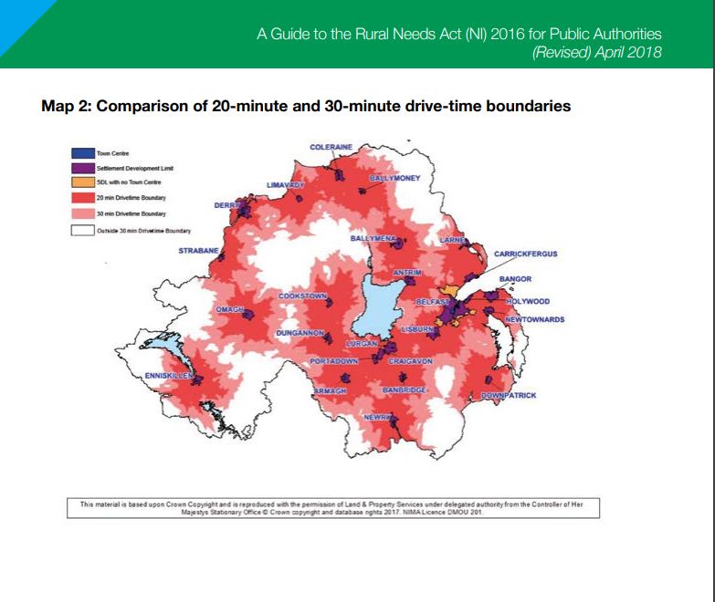

Appendix E: Parental Consultation

This form received 69 responses.

Nursery Provision at Braidside IPNS
November 2023
The Board of Governors of Braidside Integrated Primary and Nursery School are keen to consult with parents and carers to obtain your view on Nursery provision within the school. At present we provide a half-day (morning) session with 26 places. At this point we are gathering information and gauging interest in extending this provision. To assist we would ask as many parents as possible to contribute your views.
Responses can be left to the school office by 22nd December 2023.
Thank you!
- Did your child / children attend a Nursery Unit or Nursery School? (Please tick)
- YES 88.4%
- NO

- If yes, please provide the name of the Nursery in the space below:
__53.6% attend BIPS, range of other nurseries named.______

- Did you apply for a place at Braidside Integrated Nursery Unit and were unsuccessful?
- YES 18.8%
- NO

- Would you have preferred your child/ children to receive their preschool education at Braidside Integrated Nursery Unit, if you were unsuccessful?
- YES 44.9%
- NO
- NOT APPLICABLE

- Do you feel it is important for your child/ children to attend a preschool/ nursery in the same setting as their primary school?
- YES 85.5%
- NO

- Do you have a younger child/ children who will be attending nursery school in the future?
- YES 40.5%
- NO
- Will you be selecting Braidside Integrated Nursery Unit as the first choice for your child/ children?
- YES 47.8%
- NO
- NOT APPLICABLE 47.8%

- Do you worry about moving your child from their nursery setting to a different nursery school setting?
- YES 18.8%
- NO
- NOT APPLICABLE

- What do you consider are the potential benefits of having 2 Nursery sessions available at Braidside Integrated Nursery Unit?
______Range of answers ________________________________________________________________________________________________________________________________________________________________________________________________
- Which Nursery session would you prefer?
- Morning 73.9%
- Afternoon

- Would you be willing to support us in taking forward a Development proposal to the Dept of Education to establish a second session at Braidside Nursery Unit?
- YES 89.9%
- NO

- Any additional comments
“A full day sessions for working parents would be ideal”
“Excellent Nursery setting and teacher”
“I wouldn’t be able to do an afternoon session but I’m sure there are families who would benefit from its availability”
“I also think having an integrated nursery/ school having full-time positions would be very beneficial. At the present there are only two nurseries in the area that are full-time and again theses are over-subscribed.”
“Fantastic school and staff- the ethos is dynamic at Braidside. We love the commitment to integration and this growth is exciting”.
“Good luck with the psoposal”
“Excellent Nursery facility with amazing staff”
“Children applying for the primary school also benefit with a nursery session to make the transition to P1 easier”
“Children that need to attend nursery at this point were born during covid. They already had interaction cut to a minimum. Having a few hours in a nursery will be great for their little developing minds”
“I have heard great things about the Nursery and think it would be great if there were two sessions available.”

Appendix F: Feeder pre-school providers who have contributed to Braidside IPNS Primary 1 for the past 4 years

Nursery Provider | Academic Year
Nursery Provider | 2020/2021 | 2021/2022 | 2022/2023 | 2023/2024
Braidside IPNS NU | 25 | 23 | 24 | 25
Ballymena NS | 2 | 3 | 4 | 5
Dunclug NS | 7 | 7 | 4 | 8
Millennium IPS NU | 0 | 0 | 0 | 1
Harryville NU | 1 | 0 | 1 | 0
Steeple NU | 0 | 1 | 0 | 0
Ballykeel PS NU | 1 | 3 | 0 | 2
Mill Strand PS NU | 1 | 0 | 0 | 0
Country Pre-school PG | 0 | 0 | 0 | 1
Ballee Pre-school PG | 1 | 3 | 0 | 2
Kirkinriola Early Years PG | 0 | 0 | 0 | 1
Broughshane Centre of Early Learning PG | 0 | 1 | 1 | 1
High Kirk PG | 0 | 1 | 1 | 0
First Steps | 1 | 2 | 3 | 0
St Patrick’s PG | 0 | 0 | 1 | 0
Hollywood PG | 0 | 0 | 1 | 0
Gracehill PG | 0 | 0 | 2 | 0
None | 1 | 1 | 5 | 2

Appendix G: Nursery unit figures over the last three years numbers of five cases or less are supressed
Year | Number of units | Number of units which have no Catholics in them | Number of units which have no Protestants in them | Total number with no religious mixing | Number of units which have a religious mix of at least 10% Catholic and 10% Protestant including Integrated NUs  (% of the total number of NU in NI) | Number of the religiously mixed units which are integrated*,  % of the total number of NU in NI which have a 10% mix
2022/23 | 255 | 31 | 92 | 123 (48.2%) | 43 (16.9%) | 19 (44.2%)
2021/22 | 250 | 26 | 86 | 112 (44.8%) | 39 (15.6%) | 13 (33.3%)
2020/21 | 248 | 35 | 88 | 123 (49.6%) | 39 (15.7%) | 18 (46.2%)
*There are currently 22 Integrated nursery units, but some have numbers supressed due to being 26 place settings.
Source: DE statistics

Appendix H: Nursery School figures over the last three years numbers of five cases or less are supressed- Source DE
Year | Number of nursery schools | Number of nursery schools which have no Catholics in them | Number of nursery schools which have no Protestants in them | Total number with no religious mixing | Number of nursery schools which have a religious mix of at least 10% Catholic and 10% Protestant,  % of the total number of nursery schools in NI
2022/23 | 93 | 6 | 34 | 40 (43.0%) | 22 (23.7%)
2021/22 | 94 | 5 | 24 | 29 (30.9%) | 22 (23.4%)
2020/21 | 95 | 5 | 34 | 39 (41.1%) | 29 (30.5%)

Appendix I: Preschool Playgroup figures over the last three years numbers of five cases or less are supressed- Source DE
Year | Number of preschool settings | Number of preschool settings which have no Catholics in them | Number of preschool settings which have no Protestants in them | Total number with no religious mixing | Number of preschool settings which have a religious mix of at least 10% Catholic and 10% Protestant
2022/23 | 350 | 97 | 173 | 270 (49.4%) | 27 (7.7%)
2021/22 | 356 | 85 | 112 | 197 (55.3%) | 36 (10.1%)
2020/21 | 362 | 96 | 166 | 262 (72.4%) | 40 (11.0%)

Appendix J: Applications & Admissions to Funded Pre-School Settings within a 5 mile radius of Braidside IPNS 2018/19 – 2022/23
PRE-SCHOOL | APPLICATIONS & ADMISSIONS
 | 18/19 |  |  |  | 19/20 |  |  |  | 20/21 |  |  |  | 21/22 |  |  |  | 22/23
 | Adm No | 1st Prefs | Total Apps | Adms | Adm No | 1st Prefs | Total Apps | Adms | Adm No | 1st Prefs | Total Apps | Adms | Adm No | 1st Prefs | Total Apps | Adms | Adm No | 1st Prefs | Total Apps | Adms
Kenbaan Community PG | 26 | 33 | 33 | 26 | 26 | 33 | 35 | 26 | 26 | 33 | 37 | 26 | 26 | 35 | 36 | 26 | 26 | 33 | 36 | 26
Dunclug NS FT | 26 | 77 | 86 | 26 | 26 | 79 | 93 | 26 | 26 | 98 | 116 | 26 | 26 | 78 | 90 | 24 | 26 | 72 | 86 | 26
Dunclug NS PT | 52 | 26 | 84 | 52 | 52 | 36 | 83 | 52 | 52 | 28 | 113 | 51 | 52 | 11 | 68 | 52 | 52 | 27 | 86 | 51
First Steps Pre-School | 13 | 10 | 13 | 13 | 18 | 5 | 13 | 13 | 22 | 15 | 24 | 22 | 14 | 8 | 13 | 13 | 15 | 6 | 13 | 13
High Kirk Community PG | 16 | 19 | 21 | 16 | 17 | 22 | 24 | 16 | 17 | 15 | 20 | 17 | 17 | 13 | 14 | 14 | 17 | 23 | 26 | 16
Kirkinriola EY PG | 17 | 17 | 21 | 17 | 17 | 16 | 26 | 17 | 17 | 14 | 14 | 14 | 15 | 12 | 15 | 15 | 17 | 16 | 17 | 17
Ballymena NS | 104 | 101 | 141 | 102 | 104 | 86 | 130 | 103 | 104 | 99 | 155 | 104 | 104 | 74 | 110 | 102 | 104 | 91 | 143 | 104
Ballykeel NU | 52 | 61 | 71 | 52 | 52 | 68 | 77 | 52 | 52 | 62 | 76 | 52 | 52 | 60 | 69 | 52 | 52 | 61 | 67 | 52
Harryville NU | 26 | 34 | 37 | 26 | 26 | 23 | 31 | 25 | 26 | 23 | 29 | 26 | 26 | 22 | 26 | 25 | 26 | 26 | 30 | 26
Ballee Pre-School | 26 | 32 | 33 | 26 | 28 | 28 | 31 | 28 | 42 | 41 | 44 | 42 | 28 | 33 | 35 | 28 | 29 | 29 | 29 | 29
Braidside NU | 26 | 35 | 39 | 26 | 27 | 40 | 62 | 27 | 26 | 45 | 63 | 26 | 26 | 44 | 58 | 26 | 26 | 53 | 71 | 26
Broughshane NU | 26 | 39 | 34 | 26 | 26 | 42 | 48 | 26 | 27 | 36 | 47 | 27 | 26 | 32 | 41 | 26 | 26 | 36 | 46 | 26
Broughshane PG | 26 | 28 | 32 | 26 | 26 | 29 | 41 | 26 | 26 | 21 | 26 | 26 | 26 | 26 | 28 | 26 | 26 | 14 | 15 | 15
Gracehill & Galgorm Comm PG | 26 | 26 | 35 | 26 | 26 | 25 | 27 | 26 | 26 | 24 | 33 | 26 | 26 | 23 | 38 | 26 | 26 | 21 | 22 | 22
Gracehill NU | 26 | 33 | 41 | 27 | 27 | 34 | 41 | 27 | 26 | 39 | 52 | 27 | 26 | 29 | 50 | 26 | 26 | 38 | 52 | 26
Buick Memorial NU | 26 | 26 | 27 | 26 | 26 | 30 | 34 | 25 | 26 | 33 | 37 | 26 | 26 | 51 | 56 | 26 | 26 | 36 | 45 | 26
Ladybirds PG | 40 | 56 | 57 | 40 | 40 | 43 | 44 | 40 | 50 | 54 | 60 | 50 | 42 | 64 | 67 | 42 | 42 | 43 | 44 | 42
The Country Pre-School | 23 | 21 | 22 | 20 | 23 | 23 | 28 | 23 | 38 | 38 | 39 | 38 | 38 | 24 | 25 | 25 | 30 | 29 | 30 | 29
Ahoghill & District PG | 18 | 18 | 26 | 18 | 18 | 15 | 18 | 18 | 20 | 20 | 23 | 20 | 26 | 27 | 35 | 26 | 24 | 18 | 20 | 20

Source: EA Statutory settings may include underage applications

Appendix K: Underage Applications and Admissions to Statutory Providers in a five mile radius of Braidside IPNS 2018/19 – 2022/23
Statutory Provider | Enrol Number | Underage Applications |  |  |  |  |  |  |  |  |  | Total Underage Admissions
 |  | 18/19 |  | 19/20 |  | 20/21 |  | 21/22 |  | 22/23 |  | 18/19 | 19/20 | 20/21 | 21/22 | 22/23
 |  | 1st Prefs | Total Apps | 1st Prefs | Total Apps | 1st Prefs | Total Apps | 1st Prefs | Total Apps | 1st Prefs | Total Apps
Braidside NU | 26 | 3 | 6 | 10 | 27 | 11 | 27 | 10 | 17 | 17 | 33 | 0 | 0 | 0 | 0 | 0
Ballykeel NU | 52 | 5 | 12 | 7 | 18 | 4 | 17 | 5 | 8 | 7 | 12 | 0 | 0 | 0 | 0 | 0
Ballymena NS | 104 | 23 | 37 | 30 | 62 | 24 | 60 | 25 | 40 | 30 | 72 | 3 | 28 | 9 | 33 | 33
Broughshane NU | 26 | 3 | 5 | 1 | 12 | 5 | 13 | 5 | 13 | 17 | 26 | 0 | 0 | 0 | 0 | 6
Buick Memorial NU | 26 | 4 | 4 | 9 | 14 | 6 | 9 | 15 | 19 | 5 | 12 | 3 | 5 | 0 | 0 | 0
Dunclug NS FT | 26 | 8 | 12 | 15 | 30 | 21 | 28 | 9 | 16 | 14 | 23 | 0 | 0 | 0 | 0 | 0
Dunclug NS PT | 52 | 16 | 32 | 24 | 45 | 14 | 46 | 3 | 18 | 12 | 40 | 0 | 10 | 0 | 2 | 5
Gracehill NU | 26 | 1 | 2 | 7 | 13 | 5 | 17 | 4 | 12 | 12 | 22 | 0 | 0 | 0 | 0 | 0
Harryville NU | 26 | 10 | 11 | 10 | 19 | 7 | 12 | 6 | 7 | 4 | 8 | 0 | 8 | 9 | 6 | 4
Total |  | 73 | 121 | 113 | 240 | 97 | 229 | 82 | 150 | 118 | 248 | 6 | 51 | 18 | 41 | 48
Source: EA

Appendix L: Pre-School Settings within a 5 mile radius of Braidside IPNS - Religious Breakdown 2022/23

School name | Protestant | % Protestant | Catholic | % Catholic | Other Christian/ non-Christian/ no religion/ unknown | % Other Christian/ non-Christian/ no religion/ unknown | Enrolment
The Country Playgroup | # | # | * | * | 0 | 0 | 30
Gracehill and Galgorm PG | 12 | 50 | 0 | 0 | 12 | 50 | 24
First Steps Playgroup | 0 | 0 | 0 | 0 | 14 | 100 | 14
Broughshane Centre of Early Learning | # | # | * | * | * | * | 17
High Kirk Community PG | 9 | 52.94 | * | * | # | # | 17
Ballee pre-School PG | 0 | 0 | 0 | 0 | 33 | 100 | 33
Ahoghill & District Comm Pre-School PG | 0 | 0 | 0 | 0 | 18 | 100 | 18
Kenbaan Community PG | 0 | 0 | # | # | * | * | 26
Kirkinriola Early Years | 10 | 58.82 | * | * | # | # | 17
Ladybirds Playgroup | # | # | * | * | * | * | 41
Dunclug NS | 12 | 15.38 | 22 | 28.21 | 44 | 56.41 | 78
Ballymena NS | 41 | 38.68 | 18 | 16.98 | 47 | 44.34 | 106
Ballykeel NU | 26 | 50 | * | * | # | # | 52
Harryville NU | 11 | 40.74 | 0 | 0 | 16 | 59.26 | 27
Broughshane NU | 15 | 57.69 | 0 | 0 | 11 | 42.31 | 26
Gracehill NU | 18 | 66.67 | 0 | 0 | 9 | 33.33 | 27
Buick Memorial NU | 14 | 50 | * | * | # | # | 28
NB: This data is collected annually through the school census exercise in October. Figures are a snapshot of the situations in schools at that time.
Source: DE School Level Data /DE Pre-School Data 2022/23
Key:
- | means zero cases.
* | refers to less than five cases where data is considered sensitive.
# | means figure has been supressed under rules of disclosure.

A Fair Start (education-ni.gov.uk)
https://www.nisra.gov.uk/statistics/deprivation/northern-ireland-multiple-deprivation-measure-2017-nimdm2017
https://explore.nisra.gov.uk/area-explorer-2021/N10000801/
https://www.education-ni.gov.uk/sites/default/files/publications/education/Newcomer%20Pupils%202022.23.pdf
https://www.education-ni.gov.uk/sites/default/files/publications/education/School%20Meals%20Statistical%20Bulletin%202022_23.pdf
https://www.ninis2.nisra.gov.uk/InteractiveMaps/Population/PopulationProjections/atlas.html?indicator=i2&prop_legendClassifier=customClassifier&pal_defaultPaletteId=Sequential%20Cyan&pal_defaultSchemeId=categoricScheme1&pal_noClasses=5&bbox=-925513.8445%2C7073689.394281939%2C-589375.7455%2C7523847.905718062&select=N09000006&printmode=true
https://www.nisra.gov.uk/sites/nisra.gov.uk/files/publications/MYE20-Factsheets.pdf
Commissioning Prospectus (nihe.gov.uk)
https://www.nihe.gov.uk/getattachment/2b78d534-0855-4af8-b8a2-bc6ba3afce35/Commissioning-Prospectus.pdf
.https://www.education-ni.gov.uk/sites/default/files/publications/education/DP%20568%20%20Spires%20IPS%20-%20%20Redacted%20Officials%20Submission%20for%20website%20THIS%20ONE.pdf
https://www.education-ni.gov.uk/sites/default/files/publications/de/a-framework-for-ey-education-and-learning-2013.pdf
The rural needs map (see Appendix D) developed in connection with the Rural Needs Act (2016) concentrates on driving distances from centres of services to assess the rurality of an area. The data from the Census 2021 Area Explorer highlights travel by car as the main method of transport for people in the Ballymena Area.
A Strategy for Integrated Education in Northern Ireland - April 2023_0.pdf (education-ni.gov.uk)

