Easy Read

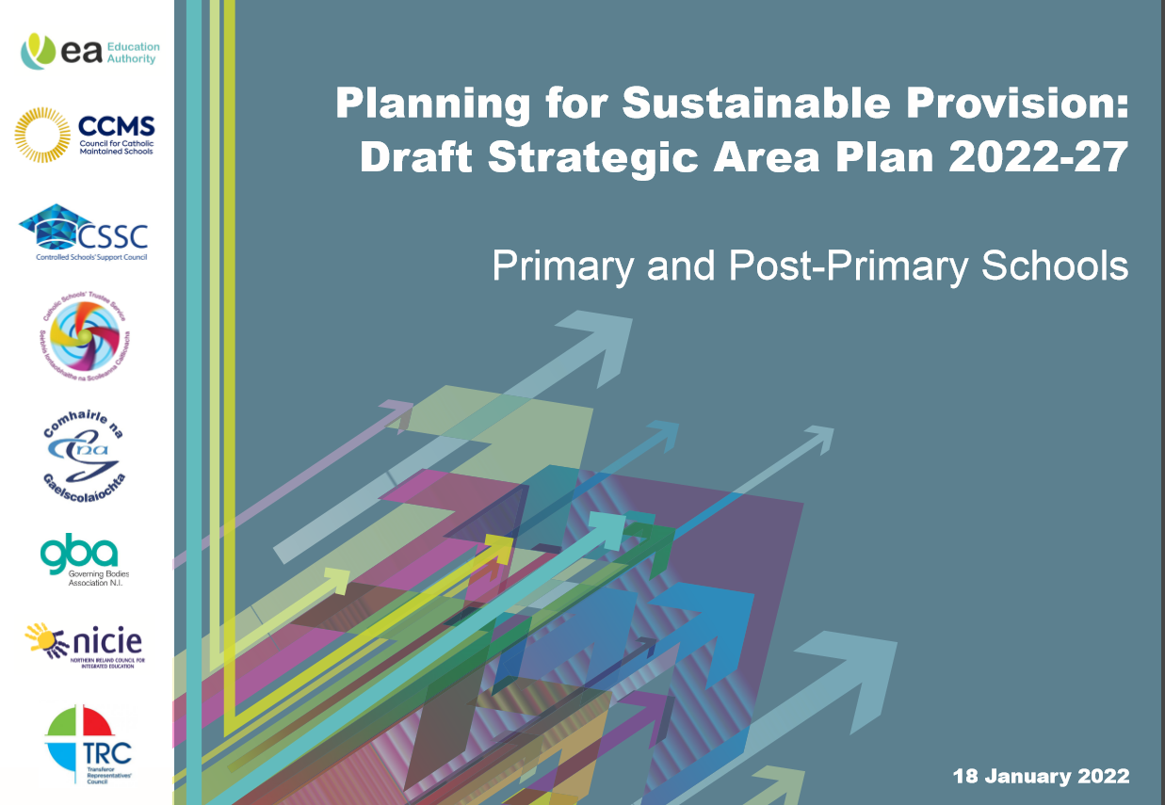

Contents

Who are we? | 3
What do we want to do? | 4
Background | 5 – 8
What are we going to do? | 9
Getting people’s views | 10
How can I put forward my views and comments? | 11
What happens next? | 12

Who are we?

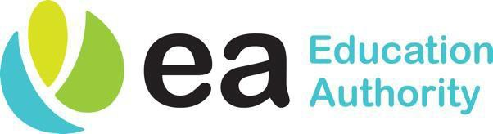
- The Education Authority (EA) is responsible for education services in Northern Ireland including schools and support services.

- The EA’s job is to make sure that children and young people’s needs are being met.

What do we want to do?

- The EA is asking for your views on a draft Strategic Area Plan.

- A strategy is a plan over a long time. This draft Strategic Area plan is for 5 years.

- Your views will help us to write the final plan.

Background

- There are too many schools for the number of pupils.

- There has been a drop in the number of pupils.

- Some schools have a small number of pupils.

- Some schools have the right number of pupils and some schools have too many pupils.

Background

  - Area Planning will improve the quality of educational provision for all pupils by:

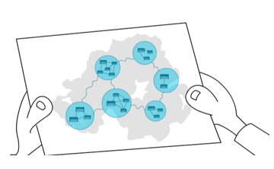
Providing a network of sustainable schools that are of the:
- right type,
- the right size,
- located in the right place at the right time.

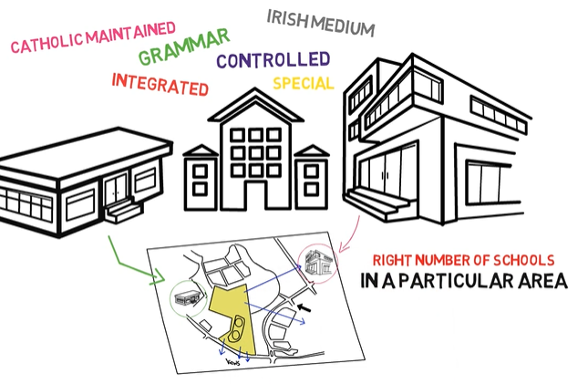

Background

- To help us in Area Planning there are four Key Themes:

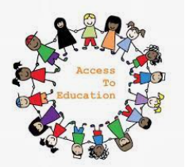

- Equal access to education

- Sharing and working together

Background

- Use resources well

- Money for classrooms and buildings

What are we going to do?

- We want to provide all pupils a high quality educational experience in sustainable schools.

- We want to help all children and young people to succeed.

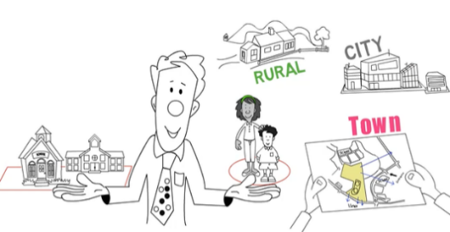

- We want to make sure there are enough schools for now and for the future.

Getting people’s views

- To find out what people think about the draft plan we are holding a public consultation. At this consultation, everyone will be able to give us their views.

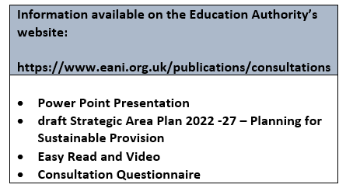
- We are having online meetings on:
3 February 2022
9 February 2022
2 March 2022
10 March 2022

- We want to hear the thoughts of children and young people. The Education Authority’s Youth Service will meet with children and young people.

How can I put forward my views and comments?

You can …….

- Tell us what you think by going online and filling out a form:
https://www.eani.org.uk/publications/consultations
- Go to an online consultation meeting and give your comments.

- Write to the EA: DraftSAP2@eani.org.uk
or
Education Authority
Education Directorate, Area Planning
17 Lough Road
Antrim BT41 4DH

What happens next?

  - The consultation will be from

Tuesday 18 January 2022 (12 noon)
to
Tuesday 12 April 2022 (5 pm)

- The Education Authority will think carefully about what you have told us.

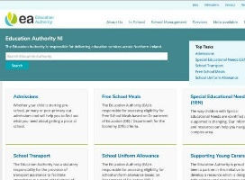

- You can find a summary of what everyone has said at www.eani.org.uk.

