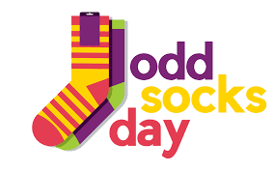
Anti-Bullying Week 2021

Dear Parents/ Carers,

This year, we are celebrating Odd Socks Day. Odd Socks Day is a chance for Primary schools to celebrate Anti-Bullying Week in a positive way by asking pupils to wear odd socks to school. Odd Socks Day is an opportunity to have fun, be yourself and spread awareness of the core values Anti-Bullying Week promotes. There is no pressure to wear the latest fashion or buy expensive costumes. All you have to do to take part is wear odd socks, it couldn’t be simpler!

Odd Socks day will take place on the first day of Anti-Bullying Week, Monday 15th November. The rest of your child’s school uniform should be worn as normal.

As a school, we will be participating in a range of activities throughout the week, in line with our ‘Health and Well-Being’ action plan. We hope that the children will enjoy the week and find it valuable.

Yours sincerely,
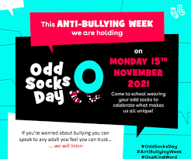
Mrs K McLaughlin
