in





**Important Upcoming dates for your Diary**

**Happy Healthy Kids Remote Workshop - Friday 16th March**





***Happy Birthday this month to:***

**Sienna**

**APRIL IN THE NURSERY**

MC900024461[1]MC900216660[1]MC900216664[1]****

j0195384MC900292360[1]Our theme this month is ’People at Work’

This month, we will be learning about different jobs people do - jobs in our school (eg. lollipop lady), jobs people do to help us stay healthy and safe (eg. dentist, police), jobs people do in shops (eg. hairdresser), and jobs people do to provide for us (eg. farmer, chef, binman). Normally, we would have been having visits from various occupations (eg. police, vet, optician), but due to COVID, we will not be able to do that this year. However, if you do a job you feel the children could learn about, please send in a photo and we will be happy to talk about it!



In colour this month, we will be looking at the colour pink, and at the idea of multi-coloured (eg. all the colours of the rainbow).





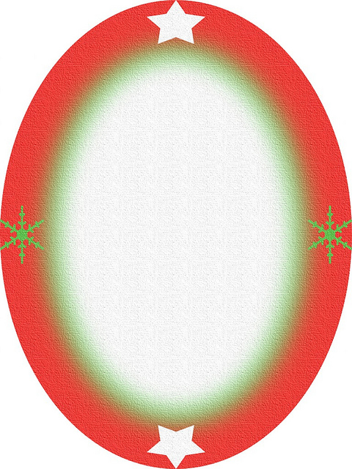

The shapes we are learning about are an egg or oval shape, and a flower.

 We will be talking about the number 9.



The concept we will look at is the idea of pattern.

Our Personal Development focus this month is ‘Waiting for our Turn’ (eg. we will start to learn about putting our hands up and waiting for our turn to speak).

**MCj00890480000[1]**



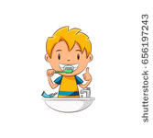Our independence target is to learn to make choices (eg. in play).

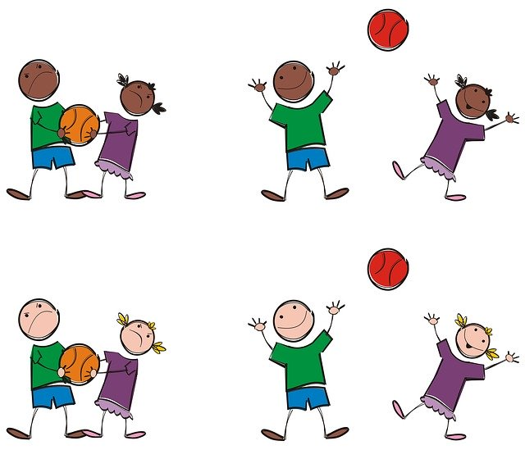

Our Physical Development focus are ball skills, and to strengthen our pincer grip.



The nursery rhymes and songs we are learning are written out for you overleaf so you can have fun practising them at home!

1. Do you know these jobs that people can do?

2. What sort of uniforms do they wear? (hats, boots, coats, etc)

3. What tools do they need? (computer, hammer, hoses, etc)

4. What vehicle do they use for their job? (car, van, lorry, engine, truck, tractor, bike)

5. What noises do they make doing their work? (siren, banging, snipping, drilling, etc)

|  |  |  |
| --- | --- | --- |
| **builder**  MC900390932[1] | **farmer**  MC900233188[1] | **doctor/nurse**  MC900334028[1] |
| **hairdresser**  MC900195390[1] | MC900045095[1]**dentist** | **police**  MC900013641[1]MC900056771[1] |
| **shopkeeper**  MC900360956[1] | **firefighter**  MC900389398[1] | **teacher**  MC900060317[1] |
| **postman**  MC900360940[1] | **office worker**  MC900360964[1] | **mechanic**  MC900360906[1] |
| MC900347397[1]MC900195400[1]**chef** | **pilot**  MC900370426[1] | **lollipop person**  MC900088984[1] |
| **recycling officer**  MC900334020[1] | **Vet** | MC900355913[1]MC900232728[1]**Popstar** |



See-saw, Margery Daw, Here we go gathering nuts in May,

Johnny shall have a new master; Nuts in May, nuts in May.

He shall have but a penny a day, Here we go gathering nuts in May

Because he can’t work any faster! On a cold and frosty morning!





Oh, the grand old Duke of York, Rub-a-dub-dub,

He had ten thousand men! Three men in a tub;

He marched them up to the top of the hill, Who do you think they be?

And he marched them down again! The butcher, the baker,

And when they were up, they were up, The candlestick maker,

And when they were down, they were down, All scrubbing their way

 And when they were only half-way up, Out to sea!

 They were neither up nor down!



Miss Polly had a dolly who was sick, sick, sick.

So she called for the doctor to come quick, quick, quick!

 The doctor came with his bag and his hat,

And he knocked on the door with a rat-a-tat-tat!

 He looked at the dolly and he shook his head!

He said, “Miss Polly, put her straight to bed!”

He wrote on his paper for a pill, pill, pill.

“I’ll be back in the morning if she’s still ill!”



 (To the tune ‘Five Little Monkeys…’)

Peter bangs with one hammer, Five little fire crew standing in a row.

One hammer, one hammer, 1, 2, 3, 4, 5 they go!

Peter bangs with one hammer, They hop on the engine and give a shout!

All day long! And quicker than a flash, the fire is out!

(Repeat with two…three…four…five…) (Repeat with four…three…two…one…)

MC900312406[1]

Hi Ho, Hi Ho, it’s off to work we go! Just whistle while you work! (whistle)

MC900437992[1] We keep on singing as we clean! And cheerfull-ly, together we

Hi Ho, Hi Ho! (repeat) Can tidy up the place! 