in





**Important Upcoming dates for your Diary**

**Science Week - Fri 5th to Fri 12th Mar**

**Back to Nursery - Mon 8th to Fri 19th Mar**

**Integrated Education Week - Mon 15th to Fri 19th Mar**

**Easter Holidays begin - Mon 29th Mar**





***Happy Birthday this month to:***

**Matthew, Eilidh, Lexi, Austin, Ethan**

**MARCH IN THE NURSERY**



C:\Users\John\AppData\Local\Microsoft\Windows\Temporary Internet Files\Content.IE5\5AS90R0B\MC900352094[1].wmf

**Our theme this month is ‘On the Move’ or**

C:\Program Files\Microsoft Office\MEDIA\CAGCAT10\j0212957.wmf

C:\Users\John\AppData\Local\Microsoft\Windows\Temporary Internet Files\Content.IE5\I6D4UQG7\MC900237520[1].wmf

MC900358061[1]**‘Wheels, Waves, and Wings’**

**We will be learning all about different kinds of transport that travel on land, on the water, and in the air. Please talk with your child about the different types of vehicles they can see or hear, about the different jobs they do, journeys they go on, about road safety, even go see the train station! We will also be looking at movement in general, especially our body movements and what activities we can do to keep our bodies growing strong and healthy. To help us with part of our learning in this topic, please encourage your children to be doing physical activity every day! Thank you!**



**In colour this month, we will be looking at the idea that colours sometimes mean something (eg. red can mean danger), and also the colour orange.**



MC900361726[1]

**The shape we are learning about is a cone.**

**We will be talking about the number 8.**

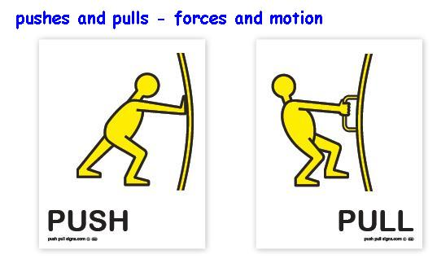

**The concept we will be looking at is the idea of push and pull forces.**

**Our Personal Development focus this month is ‘Being Careful’. We will talk about how we stay safe at Nursery by using our ‘looking eyes’, ‘walking feet’, by sitting on our bottoms, pushing in our chairs, and picking things up when they fall on the floor.**

**Our independence target is to keep ourselves safe (eg. by holding an adult’s hand when crossing the road, by not running off, by wearing our seatbelt and helmets, etc)**



**Our Physical Development target is to develop our range of body movements (eg pedalling).**

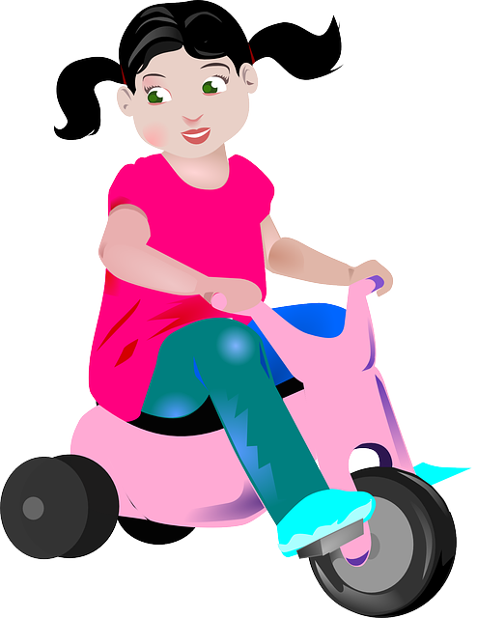

**The nursery rhymes and songs we are learning are written out for you overleaf, so you can have fun practising them at home!**

**1. Do you know these vehicles?**

**2. Do you know where they travel? (on the road, on a track, in a**

**field, on the water, in the air)?**

**3. What noises do they make? (Vroom, choo-choo, toot-toot)**

**4. What jobs do they do? (dig, go on journeys, help in emergencies)**

**5. Can you name their parts? (eg. wheels, roof, engine, wings)**

**6. How many of each part do they have? (eg. 2 wings, 4 wheels)**

|  |  |  |
| --- | --- | --- |
| **car**  MC900434818[1] | **aeroplane**  MC900320992[1] | MC900321004[1]**motorbike** |
| **fire engine**  MC900389398[1] | MC900355691[1]**train** | MC900326676[1]**boat** |
| **digger**  MC900318258[1] | MC900295612[1]**horse** | MC900320972[1]**ambulance** |
| **bicycle**  MC900045138[1] | MC900311222[1]**lorry** | MC900320934[1]**bus** |
| **helicopter**  MC900321000[1] | MC900326670[1]**tractor** | MC900290359[1]**spaceship** |

