



**Important Upcoming dates for your Diary**

**Happy Healthy Me Launch - Mon 22nd to Fri 26th Feb (details to follow)**

**Mid-Year interviews - Mon 8th Feb through to Mon 15th Feb**

**Half-term - Tue 16th through to Fri 19th February**

***Happy Birthday this month to:***

**Aayush, Eli, Izzy**





**FEBRUARY IN THE NURSERY**



C:\Users\JohnTurner\AppData\Local\Microsoft\Windows\Temporary Internet Files\Content.IE5\DAQN8EV4\MC900434969[1].wmf

**Our theme this month is ‘Happy Healthy Me’**

**Please take every opportunity this month to talk about exercise and food with your child – where it comes from, why we need it, which foods are healthy or unhealthy etc. A website you may find useful can be found at** [**www.parentsforhealth.org/**](http://www.parentsforhealth.org/) **We will also be looking at different themes that the children would like us to learn about, so they can get their thinking caps on and come up with some ideas!**

 

**Our colours this month are green and brown.**



**The shape we are learning about is a heart. Plus, when looking at food packaging, we will be learning about cylinders (tubes) and cuboids (boxes).**

C:\Users\John\AppData\Local\Microsoft\Windows\Temporary Internet Files\Content.IE5\D3JNMYX9\MC900112484[1].wmf

C:\Users\JohnTurner\AppData\Local\Microsoft\Windows\Temporary Internet Files\Content.IE5\Y7XPU7XQ\MC900112652[1].wmf

**We will be talking about the number 7.**

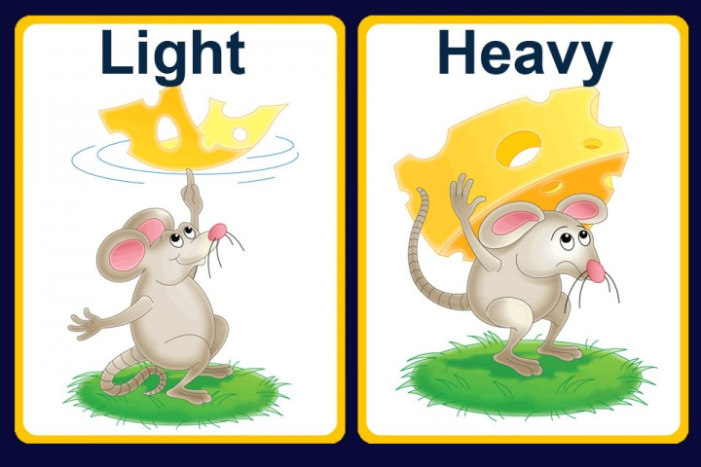

**The concept we will think about is weight - heavy and light.**



**Our Personal Development focus this month is to use our gentle inside voices in class.**



**Our independence target is to try and use cutlery to get our snack ready and to eat it.**

**Our Physical Development targets this month are to learn about making healthy choices, and developing good patterns for sleeping, eating, exercising and drinking.**



**The nursery rhymes and songs we are learning are written out for you overleaf so you can have fun practising them at home!**

**Other relevant information is attached, including important dates for your diary, such as our Happy Healthy Kids workshop, and parent interviews. February is a very busy month, with National Storytelling Week, Children’s Mental Health Week and the Northern Ireland Science Festival, so please read over all your Seesaw messages, and engage in all the activities planned for your children! Thank you for all your co-operation!**

MC900335751[1]MC900215510[1]MC900436899[1]MC900441780[1]

Can you name a food that is yellow, orange, red, green, purple?

MC900112320[1]MC900264284[1]MC900335752[1]MC900436911[1]

Can you name a fruit, a vegetable, a meat, an unhealthy food?

MC900391406[1]

MC900331401[1]MC900232579[1]Can you think of a food that grows on a plant, that grows under the ground, that comes from an animal ?

MC900215796[1]MC900232682[1]dglxasset[1]Can you find a food in a tin, in a packet, in a box, in a carton?

MC900233681[1]

Colour me!

