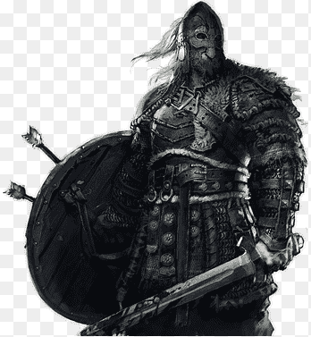

My Viking saga story.

By Johnathan Gibson.

My name is Jim Bob, my family came from Norway but we ended up settling in Ireland it’s a beautiful part of the world, we moved here in 1068. I am king of the Vikings in Ireland.
I am 32 years old, I have long black wavy hair with big bushy eyebrows and I have a big beard which is in a ponytail, my clothes are a bit different from today I have a long drape which has a bit of rope around the waist to keep it from blowing up, I wear a head band to keep my long hair from blowing in my face.

On Monday night I woke up with a lot of commotion. The Vikings from England had taken all our valuables and kidnapped some of my people and family I was so upset.
I gathered up the remainder of my Viking men and we had to make a plan to rescue our people back. Max the leader of the boats went and stocked up the boat for our journey as the weather looks like it’s going to be a stormy sail, we have our navigating sunstone to help us when the sunlight has gone and food to get us there and back. The Vikings said goodbye to their wives and families an we left for the boat.
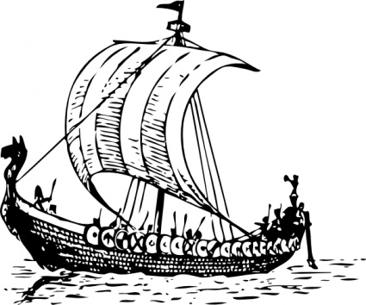
“Set the sails” Jim Bob shouted to Max and off they set to England.
As we were in the middle of the sea getting our sunstone to start navigating us in the distance I thought I saw dolphins in the far off distance but as we got closer we realised it was magical mermen. “Hello there sir” I shouted an they swam closer.

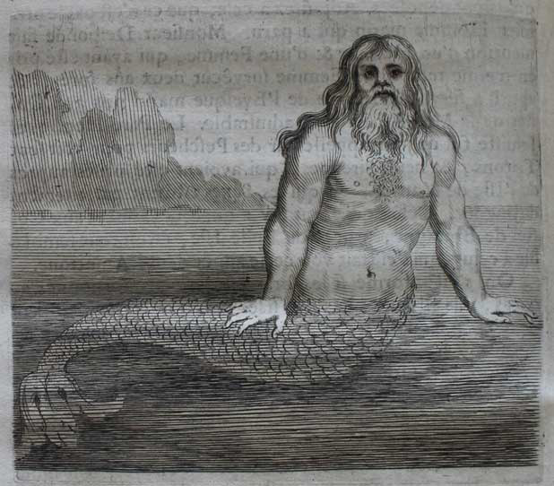
“What are yous doing out in the sea it’s such a bad night?
asked king Jasper.
“ The king of England has stole all our valuables and kidnapped some of my people and family” said Jim Bob, and as he said that the storm got worse the boat was rocking side to side.
“Hold on men” said Jim Bob the boat was getting swept away but just as we thought it was going under we felt a jerk at the back of the boat, it was Jasper and his men they pushed us through the storm and we could see England, the boat was pushed to safety.
“Thank you Jasper for saving us, now we can go and rescue my people.” And off the mermen swam into the sea.

We were standing at the sea front and I could hear the growls and see flames and big puffs of smoke coming out of the castle grounds they have a dragon, “our people must be there” shouted Jim Bob.
The men an Jim Bob got closer to the castle.
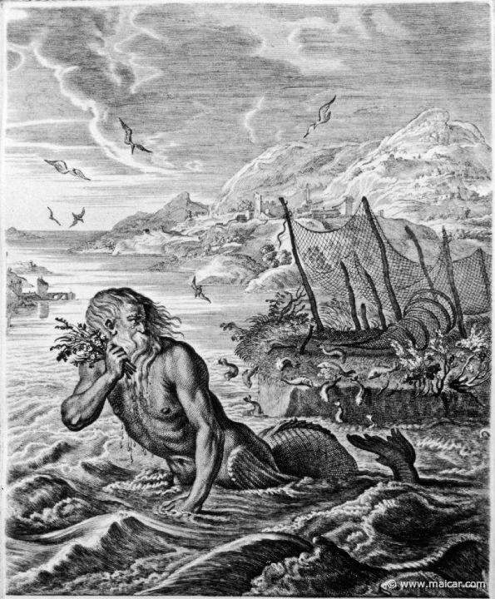
“I must use my invisibility power to get us into the castle” said Jim Bob.
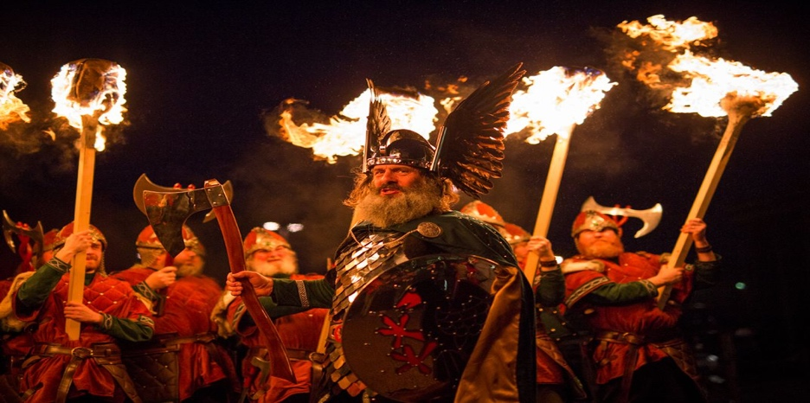
They all huddled together and became invisible, but as we got closer the dragon could smell us so the invisibility power could not save us anymore.
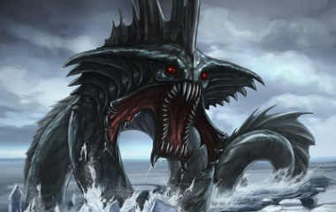
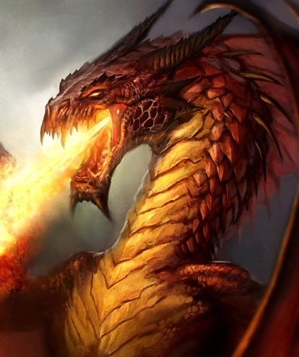
My father gave me my powers and his father gave them to him, all the men were amazed as I closed my eyes and transformed myself into a large fire breathing dragon. I am grey and black an I breath blue fire which is used to shrink everything the other dragon is a girl dragon her name is Sapphire.
She is huge and a fiery orange colour and blows green flames. She looks so scary. She has scars all over her face the other men run to our people as I confront the dragon.
She looks cross to see me she turns around and I realise she only has one eye, she must have lost her other one in a fight. I walk closer to her and she’s coming towards me not realising my men were going to my people. She hears a noise looks round to her right her blind side and just then I blow my flames at her and she turns into a baby dragon again.

The King of England looked so scared when he saw what I had done to his dragon, immediately he released all my people and got his men to give us all our valuables back, he swore he would never steal off us again. We got on the boat and I put my hand in my pocket to get my sunstone out as it was dark we needed it to navigate us back to Ireland.
“Oh no” shrieked Jim Bob.
“Our sunstone must have went over board when we went through the storm!”
“What our we going to do?” Asked his wife Anna.
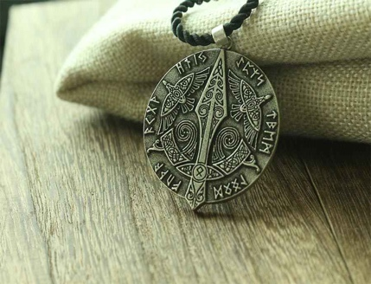
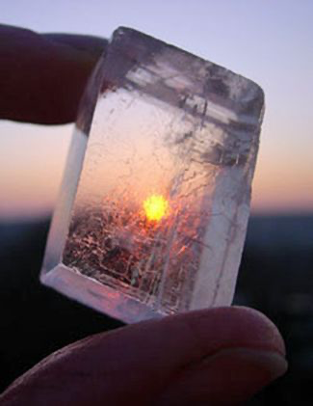
Just then Jasper the merman came back and said “look what I found at the bottom of the sea, we saw something sparkle in the sea floor and thought it belonged to you.”
“Aww thank you so much Jasper” said Jim Bob.
“ You have saved us so much today we are in debt to you.”
Jasper gave a smile and said.
“That’s what friends are for Jim Bob.”
“Hold on” said the mermen and they pushed the boat back to Ireland so Jim Bob and his people got through the stormy sea back to homeland safely. Every week the mermen and king Jim Bob met at the seafront they remained very good friends.
