



**Important Upcoming dates for your Diary**

**Christmas Jumper Day - Thu 10th Dec**

**Nursery Christmas Show - Fri 11th December online**

**Nursery Christmas Party and Pressies - date to be confirmed**

**Last Day of School - Fri 18th Dec (tbc)**

***Happy Birthday this month to:***

**Sophia, Olivia, Freya**





**DECEMBER IN THE NURSERY**

MC900410541[1]****

C:\Users\John\AppData\Local\Microsoft\Windows\Temporary Internet Files\Content.IE5\0QGMGTQ1\MC900446364[1].wmf

**Our theme this month is ‘Christmas Fun’!**



**Over December, we will be learning all about Christmas and winter (eg. the weather, birds, etc). To help us with part of our learning in this topic, please go for a walk with your child when it is frosty or snowy and discuss wintry words (eg. frosty, icy, slippy). We will also be doing lots of Christmas crafts! I’d just like to take this opportunity to wish you all a safe, happy and healthy Christmas!**

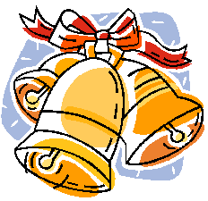



**Our colours this month are silver and gold.**



**The shape we are learning about is a star.**

**We will be talking about the numbers 4 and 5.**

**The concept we will be talking about is simple opposites, eg. up & down, in & out, on & off, dark & light, hot & cold, etc.**

**Our Personal Development focus this month is ‘Trying our Best’ and having fun! - we will try to do our best and be focused in all we do, in all our ‘work’ and play.**

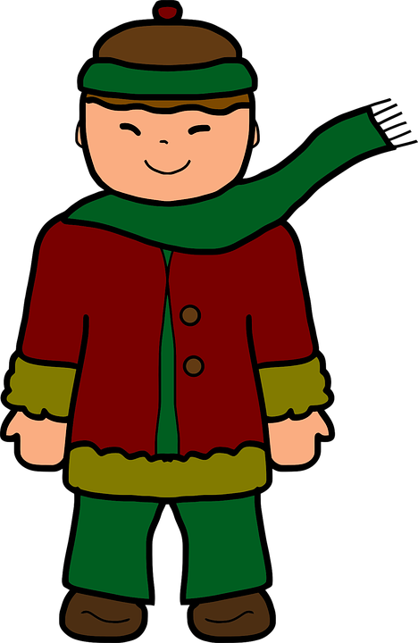

**Our independence target is to be able to take off and put on our own outdoor outdoor clothes, eg. our coat, hat, scarf and gloves.**

**Our Physical Development targets are to develop our hand-eye co-ordination, control and precision (eg. when cutting, pouring, catching)**



**Our nursery rhymes and songs are written on the back to enjoy singing at home**

**Can you tell what is happening in winter?**

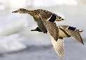MC900304879[1]MC900002032[1]MC900410815[1]MC900446346[1]MC900239421[1]MC900002032[1]MC900441413[1]MC900446348[1]MC900383324[1] 

**What happens in winter? (it is cold, trees lose leaves)**

**What clothes do we wear? (eg. coats, hats, gloves)**

**What can we play? (we can have fun in the snow)**

**What do birds do? (eat berries, fly off to hot places)**

**What do some of the animals do? (have a long sleep)**

**Why do we have a holiday off school? (for Christmas)**

**Who comes to visit on our holidays? (Santa)**

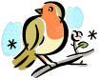

Twinkle, twinkle, little star, The north wind doth blow,

How I wonder what you are! And we shall have snow,

Up above the world so high, And what will the robin do then?

Like a diamond in the sky. P Poor thing!

Twinkle, twinkle, little star, H He’ll sit in a barn to keep himself warm,

How I wonder what you are! And hide his head under his wing.

Poor thing!

Little Jack Horner sat in a corner, We wish you a Merry Christmas!

Eating his Christmas pie! We wish you a Merry Christmas!

He put in his thumb and pulled out a plum! We wish you a Merry Christmas

And said, “What a good boy am I!” And a Happy New Year!

Jingle bells! Jingle bells! Christmas is coming, the geese are getting fat!

Jingle all the way! Please put a penny in the old man’s hat;

Oh what fun it is to ride If you haven’t got a penny, a ha’penny will do.

In a one-horse open sleigh! If you haven’t got a ha’penny, God bless you!

Here we go round the mulberry bush, I know a man with a bright red coat,

The mulberry bush, the mulberry bush, And SANTA is his name-O!

Here we go round the mulberry bush S-A-N-T-A, S-A-N-T-A, S-A-N-T-A,

On a cold and frosty morning. And SANTA is his name-O!

This is the way we wash our hands, *Repeat with:*

Wash our hands, wash our hands, I know a man with big black boots…,

This is the way we wash our hands I know a man with a long white beard…,

On a cold and frosty morning. I know a man with a big full sack…

*Repeat with: (To the tune of B-I-N-G-O)*

Scrub our face…,

Brush our teeth…

Comb our hair…,

Put on our clothes…,

Go to school… Father Christmas, x 2

He got stuck, x 2

Coming down the chimney, x 2

What bad luck! x 2

*(To the tune of Frère Jacques)*

