**BRAIDSIDE NURSERY**



**Dear parent / guardian**

**Each month we will be posting a newsletter similar to this one on our Nursery website page in order to keep you informed of what will be happening in the Nursery. These will include:**

***Any important dates and news to celebrate (eg. Birthdays)***

***Our Theme for the month***

***Things we may be collecting***

***Colours, Shapes, Numbers and Concepts we will be learning***

***Our Personal Development Focus***

***Our Independence Target***

***Our Physical Development Focus***

***Rhymes and songs to practise at home***

**We hope these newsletters will prove useful to you as we begin to co-operate together in the first stages of your child’s education.**

**Thank you for all your support! Karen Turner**

**Important things in September**

**Induction and Settling-in**



***Happy Birthday !!***

**July - Victoria**

**August - Carter, Jack, Finn**

**September - Mason**

**SEPTEMBER IN THE NURSERY**



**Our theme last month was ‘Me and My World’**

**We learned about our bodies (our faces, hands and feet), about our senses (seeing, hearing, smelling, touch and taste), and about the importance of washing our hands. We also learned about being dirty and clean, old and new things, and also about rainbows. To help us with our learning in this topic, please talk about all of these different words and concepts with your children at home.**



**Our colour last month was blue.**



**The shape we learned about was a circle.**

**We will be talking about the numbers 1 and 2.**

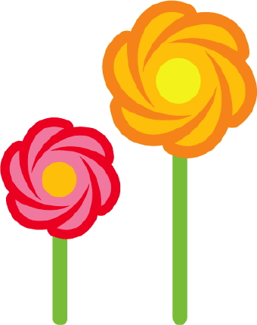

**The concept we will be thinking about is height - tall and short.**

**Our Personal Development focus this month is ‘Being Good Friends’. We will talk about being gentle and kind to each other, and playing together nicely. Please go over this with your children at home.**

**Our independence targets are to learn class routines (eg cloakroom sign-in, snack time, story time), and be able to wash our own hands.**

**Our physical development focus is to develop an awareness of the space around us, and to learn different ways of moving on our feet, and in different directions (forwards, backwards, sideways).**

**Our nursery rhymes and songs we are learning are written out for you on the back page, so you can have fun practising them at home!**

**Can you name these parts of your body?**

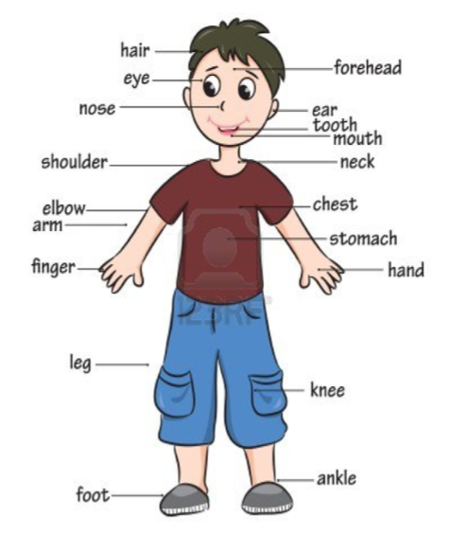

**——————— belly button**

**(tummy)**

**—— head**

**————— face**

**cheek ——————--------**

**(and lips)**

**---———— back**

**—— bottom**

**-----—— heel**

**toes ——**

**wrist ———**

**tongue ————**

**chin ——**

**eyebrows ——————**

**What parts of your body do you have only one of? (eg. a nose)**

**What parts have you two of? (eg. arms, legs)**

**What do you do with your eyes (see), your ears (hear), your nose (smell), your tongue (taste) and your fingers (touch)?**

**Can you find things in your house which make you have to use your senses? (eg. see a toy, hear a bell, smell a flower, taste a sweet, etc)**

**What can you do with your hands? What can you do with your feet?**

**Can you name all the people in your family?**

