Tens and units Addition with exchange (week 2)

Dear Primary 3 pupils and parents,
I hope that you enjoyed the introduction to exchange last week and that the children demonstrated a good understanding of the need to exchange for a ten when there are more than 9 units in the units house and of what it means to exchange and the reasoning behind it.
This week we are continuing with the process of exchanging this time including tens. Once again it is important to keep all materials you are using together in a pot and for children to individually count each unit into their hands when they are exchanging for the ten.
Similar to last week I will use dienes firstly to model each individual sum followed then by 1p and 10p coins.

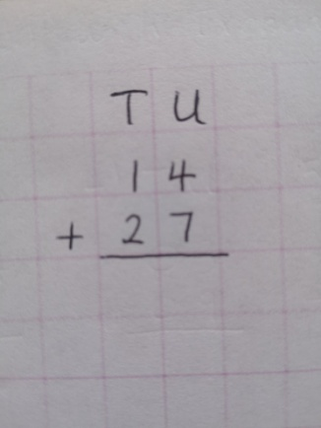 | The first sum that we are going to complete together is 14+27=.  As always we start in the Units house meaning everything under the ‘U’ and then move to the tens house meaning everything under the ‘T’. We must also remember to include our line underneath which means equals.
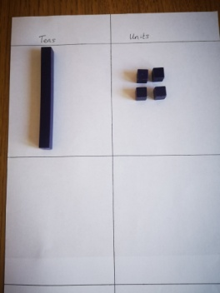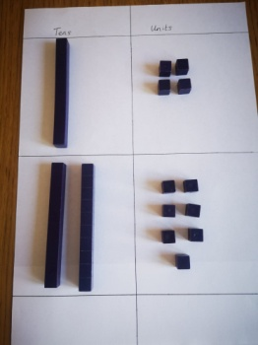 | Firstly gather your tens and units into a pot and get your tens and units card. Put out 1 ten and 4 units in the top two squares followed by 2 tens and 7 units directly underneath as demonstrated in the picture.
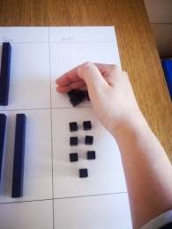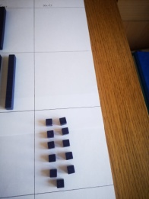  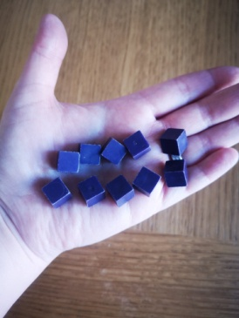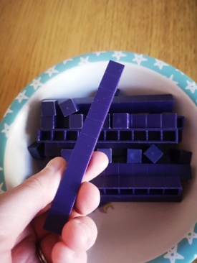 | When you have set out your sum practically remember you must always add the units first by moving all units to the bottom right answer box and counting them in twos. When you have done so your child will realise that there are 11 units and that we cannot have 11 units in the units house and therefore we must exchange.  In order to exchange it is important your child realises the reason for doing so and that they remember to count each of the ten units into their hand one at a time. Once they have done that then exchange for the ten rod.
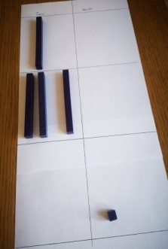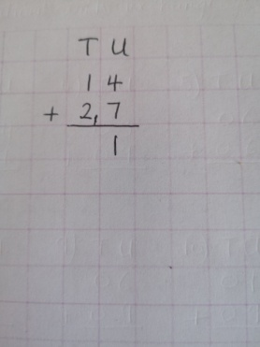 | The ten that we have exchanged should be placed in the second left hand box alongside the other tens and the findings recorded as so on the sum. The ten we have exchanged is written on this side in smaller form to remind us that it is not a 2 digit number, The 1 remaining unit is written in the unit column/house as usual.
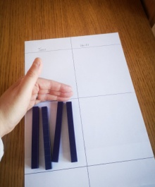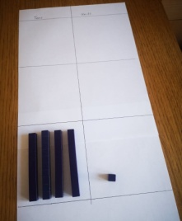 | We now move to the tens column/house and add the tens. These tens should all be moved to the bottom left hand box which is the answer section.
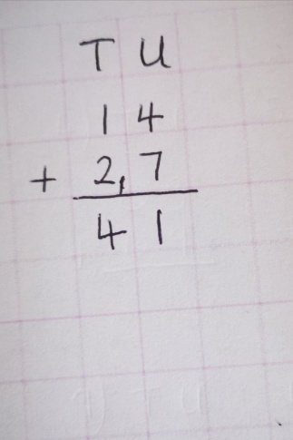 | Your child will now realise that we had 1 ten add 2 tens add the 1 ten we exchanged. They can now record this in the tens column and realise that 4 tens & 1 units = 41 which is the answer.
Now we will try our next sum using 1p and 10p coins.  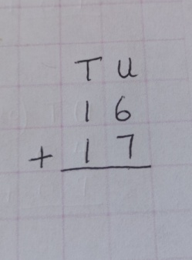 | The next sum that we will complete is 16+17= which can alternatively be written as 1 ten+ 6 units + 1 ten +7 units =
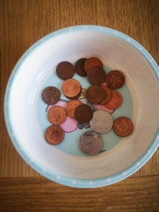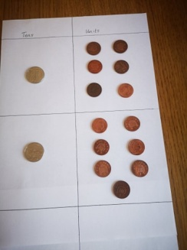 | Firstly make sure your tens (10p) coins and units (1p coins) are put into a pot. Get your tens and units card and place your coins in each column following the diagram.
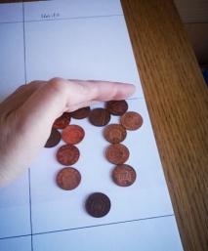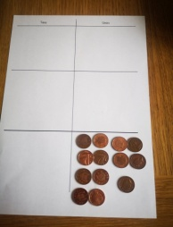 | As always we add the units first and move them to the answer box in the bottom right. Once we have counted them the children will realise that there are 13 units altogether and that as we can only have 9 units in the units house at one time we need to exchange for a ten.
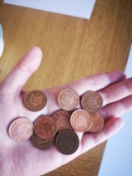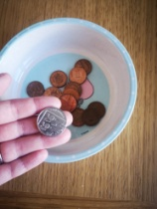 | Firstly it is important to ensure that your child counts out each of the ten units individually into their hand leaving the remaining 3 unit in the units column and then exchanges these 10 units for a 10p coin as shown in the diagram which is placed in the second left hand tens box as always.
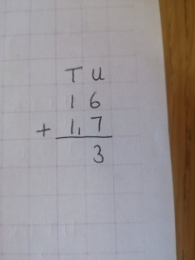 | Once this has been done then we can record the answer so far. The ten we have exchanged is now written in a small format in the tens house to remind us that it is not a 2 digit number. The remaining 3 units are written in the units section as always.
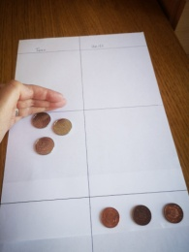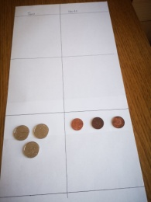 | Next we move to our tens column/house to add our tens. We had 1 ten add 1 ten add the 1 ten we exchanged. These should now be moved to the bottom left hand answer box.
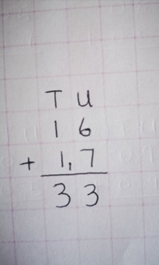 | Finally we record our tens findings on our sum before realising that the answer is 3 tens + 3 units =33.
Hopefully this has been explained in a way that is easy enough to understand. Please now have a go at the correlating sums that I have attached for this week. Many thanks, Mrs Horan.

