All About
African Giraffes

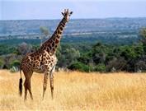

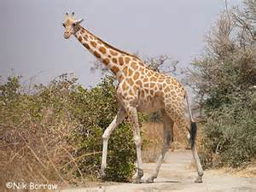

Contents:

The habitat of African
giraffes Page 3

How are African giraffes
suited to their habitat? Page 4

What do giraffes eat
and drink? Page 7

Baby giraffes Page 8

The Habitat of African Giraffes

Giraffes mainly live in savanna areas in the Africa. They normally walk around the grasslands in small groups of about half a dozen (6)

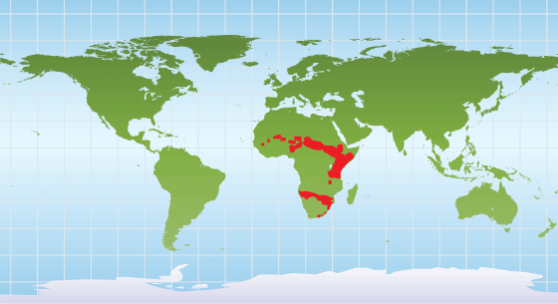

Giraffes live here.

Giraffes don’t live here.

How are Giraffes Suited
to Their Habitat?

Giraffes are the world’s tallest mammal. They are about 5 times taller than a Year 2 child! They have many interesting features including very long legs, necks and tongue.
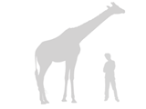

This is how tall a giraffe is compared
to a man!

As they are so tall, giraffes can eat leaves and shoots which are extremely high and which other animals can’t reach. They often look for acacia trees because they are so tall.

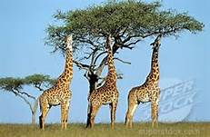

Giraffes eating from an acacia tree
How do Long Legs Help?

A giraffe's long legs mean they can run extremely fast over short distances.
As they are able to travel fast, they can run quicker than a lot of other animals which would otherwise eat them. They run in a similar style to other mammals by swinging their rear legs at the same time as their front legs.

Did you know that when giraffes walk, they move both legs on one side of their body and then both legs on the other side? Giraffes are the only animals in the world which does this!

Why do Giraffes have Long Necks?

Giraffes have very long necks. These can help them to see a long way away and look out for dangerous predators.

What are their horns for?

Male and female giraffes horns on their head. Because the males are larger, they use theirs to protect their head when they fight. This involves swinging their necks at each other in a show of strength called “necking.” Such fights aren't usually dangerous and end when one animal walks away.

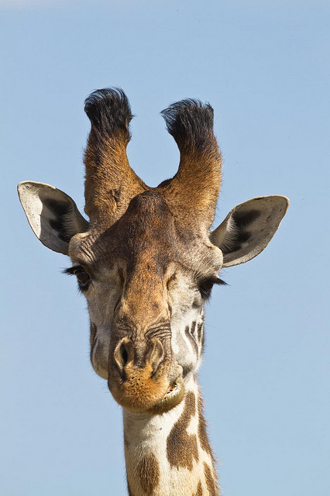

Giraffe horns
Tongue

Even the giraffe's tongue is long! This helps them pluck tasty food from branches.

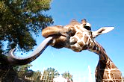

Are there any problems because they are so tall?

Although the giraffe's height helps it to keep a sharp lookout for predators, it can make it difficult and dangerous to drink at a water hole. To do this, they need to spread their legs and bend down in an awkward position. This means that predators can quite easily attack them.

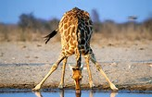

A giraffe spreading its legs so it can have a drink

What do Giraffes Eat
and Drink?

Giraffes are herbivores. Do you know what this means? A herbivore eats plants.
Giraffes spend most of their day eating. Like cows, they bring their food back up into their mouth from their stomach and chew it. A giraffe eats hundreds of pounds of leaves each week and need to travel a very long way so they can find enough food.

Giraffes only need to drink once every several days; they get most of their water from the luscious plants they eat.

Fascinating fact!
Did you know giraffes sleep for less than two hours a day?

Baby Giraffes

Female giraffes can have babies when they are 5 years old and are pregnant for 15 months (that’s longer than a year!).

Giraffes give birth while standing up. This means the babies fall to the ground when they are born. However, they can stand just half an hour after this and they are able to run with their mothers a day later.

Newborn giraffes are about 2 m tall and weigh as much as a grown up!

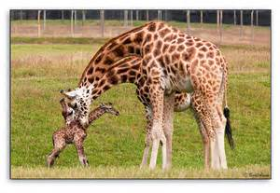
A newly born giraffe with its mother

Fun fact!
Did you know giraffes live to be about 25 years old!

