The Story of Joseph
by Leanne Guenther
This is the story about a young man named Joseph. His father's name is Jacob, and they lived in Canaan from where his grandfather was from.
Joseph was seventeen (old enough to drive a car these days), and he had eleven brothers; and only had one brother younger than him. Can you imagine having eleven brothers to play with, or fight with?
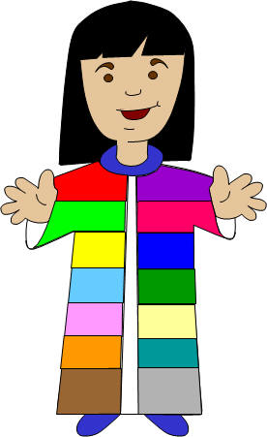Because Joseph was one of the youngest sons, his father spent more time with him, and he became very special to him. So Jacob had a special robe made for Joseph. (They didn't have jackets back then, so this was a very special jacket). It was very beautiful and had every color you could imagine in it.
All of Joseph's older brothers saw this and they got very jealous. The word jealous means that Joseph's brothers disliked him because they thought his father liked him more, and because he got the special coat. They got so jealous they couldn't even say a kind word to him.
One day Joseph had a dream, and he went to go tell his brothers. He said, "Guess what? Last night I had a strange dream. We were tying up bunches of grain out in the field when suddenly my bunch stood up, while all of yours gathered around and bowed to me." The brothers looked at each other in disgust, but Joseph continued. "Then I had another dream that the sun, moon, and eleven stars bowed down to me."
"Who do you think you are?" The brothers said. "Do you think that you are better than all of us? Do you think that we would ever bow down to you?" This made the brothers dislike Joseph even more.
When he told his father about his dreams he said, "Those are strange dreams." But he thought carefully about what Joseph had told him.
A few days later Joseph's father asked him to check on his brothers. They were in the fields quite a distance away. So Joseph went to find them.
When the brothers saw Joseph in the distance, they made a plan to kill him. But when Reuben, Joseph's oldest brother heard this he said, "Let's not kill him, just throw him in a well out here in the field." He said this because he was secretly planning to come back and rescue Joseph when the other brothers had left.
So when Joseph came to them, they took off his beautiful robe and they threw him in an empty well. A little while later a group of people came by that were wanting to sell some things in Egypt. One of the brothers spoke up, "Why don't we sell him to these people, this way we never have to see him again, and we don't have to kill him."
The other brothers liked this idea, so they sold him to the people who were going to Egypt.
Unfortunately Reuben had been working and hadn't seen what happened. When he returned to the well he noticed that Joseph was gone. He had been sold.
The rest of the brothers took Joseph's beautiful robe and dipped it in animal blood and took it back to their father. When the father saw this he cried, "Some animal has killed my son." And he cried for many days, so much that nobody could comfort him.
I wonder what will happen to Joseph now?

