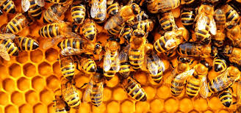
Busy Bees
Secret Life of …Bees!
The World Around Us
Art/music/media/creative writing/using maths/spelling/reading/writing

Good morning P5F!
How are you all this week? We had a very busy week last week with lots of school work on for the boys. Zac however, had a brilliant day on Wednesday! We went to our neighbour’s house (keeping socially distant) to help check her bee hives. It was soooo good that I have decided to base our creative work around this topic this week. After our visit, we learned that Wednesday was National Bee Day! How appropriate for our visit. We both learned so much and I hope you do too. I am posting some video clips from a 30 minute video. These will be called Secret Life of Bees, part 1, 2, 3 etc. There will be different reading responses for each of you to do. These will be on these Activity Notes for the week. You are all working brilliantly in creative tasks as well as core skills. This week we will focus on the creative again. Why not try connecting via Zoom or a FaceTime call with another pupil, with parents’ permission, and learn together!

How was your tea party? We had a picnic on the lawn. The weather was beautiful. Zac and I then went on a walk at Donegore Moat. Look it up. I will try and upload the video for you to watch. We walked five miles- which is rather short for us, but it was all hills! We loved it. Zac found a derelict cottage. He thinks it is over 100 years old. You can see photos of it in the video clip entitled Donegore Hike.

There are 10 tasks listed for this week. Please use them for this week and next week. I will upload just a few skills tasks then for you next week. I do not expect all ten to be completed. You have freedom to choose h0w many you do and how long you spend on them. Remember to try and stick to a routine each day.
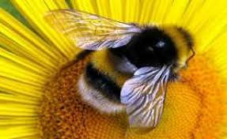
Week 6- Tuesday 26th May 2020

Activities-

- Spellings-
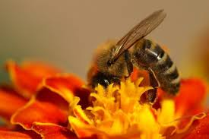
Create your own Spelling Bee words. 20 in a list…. And test someone in your family. Give yourself a break from being tested! But do make sure you know them! These words MUST be found in the video clips of Zac and the bees. Listen carefully. You will have to check the word in a dictionary to ensure you are spelling/marking it correctly. I can’t wait to see what words you choose!
- Honeycomb
- Hive
- Hexagon
- …. You complete this list

- Watch the following links on Bees online
(adult permission please)
Hyperlinks lsted below- enjoy! We did!

- Life Cycle of a Bee
- Life cycle- baby to adult-hives in a laboratory
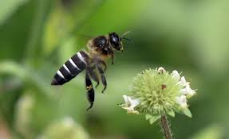
- Why are Bees important?

- Music- Flight of the Bumble bee
Zac’s video has the background music entitled, Flight of the Bumble bee.
- Listen to it on this link as well as the video.

- Please make a list of 6 reasons as to why this music reflects the movement and work of bees. Please note- the bees in our video clips are not bumble bees but working bees.

- Perform a SAFE SEARCH online- (with a parent) of this song being played online by an orchestra. Send me the link.

- What instruments do you see in the orchestra playing Flight of the Bumble Bee. What instrument finishes the song- what do you think the bee is doing at the end of the song?

- Find another video of a different performance of the song. Which one did you prefer- tell me and tell me why you liked it better. Why did it suit the day in a life of a bee, better?
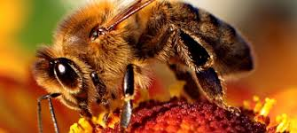

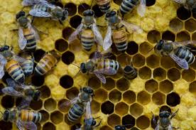
- Bullet Points-
Bullet points are where we make short notes, picking the main parts, the important points to share or learn. A bullet point has a dot at the start of it like this….
- A bee is an insect
- An insect has six legs, and three parts to its body; a head, thorax and abdomen
- Male bees do not make honey, it is the job of the female bees

Please click this link which introduces you to Bullet Points.
What are bullet points and how to use them,
In order to make good bullet points, you need to listen to our short clips (Secret Life of Bees part 1, 2,3.) and have a notebook to hand. Make brief notes as you listen to each clip. Pause the videos if you need to.
You then rewrite the notes into clear bullet points.
5 bullet points for each video clip of Zac and the bees –
Secret Life of Bees Part 1, Part 2, Part 3. (3 sets of bullet points)
Why not use lots of colour, fancy writing and titles for each clip? Enjoy designing.

- Design a fact file on bees
Decide what info you want to record. Life cycle? The Hive? Males verses Females- differences and jobs etc. Text and images required. Lots of examples online.
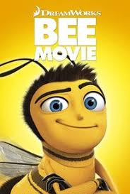
- Film Time/Cooking
Watch the full Bumble bee movie- Cinema Avo…have you ever made you own popcorn? Google how to make it. You just need the pooping corn, a saucepan with lid and a cooker. Adult required! Add salt or sugar, or both and enjoy. If you manage to do this…send me some photos!
Bee Movie Trailer
If you can’t access the bee movie- choose another film
- Design a Cartoon page ….
with a short story of a day in the life of a Worker Bee. What names will you use for your bees- be Creative and specific to their appearance, work, sounds and colours. What will the title of your cartoon beeeee? 12 cartoon boxes max. Draw them out on a large poster page and illustrate. This will take a couple of days. Plan your story and images on day one, listing phrases, vocab and story plot. Day 2- write and create. Use intriguing vocabulary!!!

- Twinkl Pack- complete the pack uploaded.

- Maths Mystery – I know how much you enjoy these!

- Bee portrait/ Use pastels/paints/crayons…whatever you have available. Make sure your full A4 or A3 page is full of colour- have a background… something like this. Choose your own image if you wish.

or a Bee Collage-Either use images online and choose
your favourite. Use a collection of materials to create
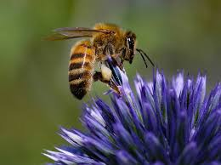
a bee collage.

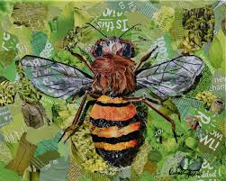

There is soo much to choose from over the next 2 weeks. Please do focus on what you can do, want to do. Try and choose a few new things from my list too, to challenge yourself.

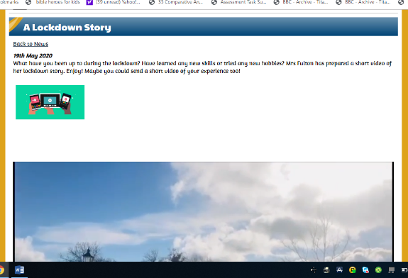
Take Care
My little Busy Beeeeeeees.

Love from Mrs Fulton- Queen Bee!

Ps….

Have you seen my Lockdown video on the school web page? A lockdown story- scroll down through more news on home page.

